Energy Unit Test
Study Guide

S8P2a Conservation of Energy
- State the Law of Conservation of Energy.
Energy is neither created nor destroyed, but it can be transformed from one type of energy to another type of energy.

- We are not supposed to use the word “lost” in regards to energy. What happens to the energy?
During energy transformations some energy may be unaccounted for due to its transformation to thermal energy.

- If a roller coaster at the top of a hill has 1000 Joules of potential energy, how much energy will there be in various forms at the bottom of the first hill? What forms of energy could be present?
According to the law of conservation of energy, there should be 1,000 joules of energy at the bottom of the first hill. Forms of energy that could be present are kinetic and thermal.

- Complete the following for a closed system:
200 J (Potential Energy) + 100 J (Kinetic Energy) → __300___ J of Thermal Energy
500 J (Chemical Energy) + 200 J (Kinetic Energy) → 600 J (Kinetic Energy) + __100_ J (Thermal Energy)

S8P2b Potential and Kinetic Energy
- What is Kinetic Energy? Give the formula.
Kinetic energy is energy of motion.
KE= ½ X M X V²

- What is Potential Energy? Give the formula for Gravitational Potential Energy.
Potential energy is stored energy. There are 3 types of potential energy: gravitational, elastic, chemical.
GPE= w X h

- A battery, a rock sitting on top of a hill, and an arrow pulled back to shoot all have potential energy. However, they are three different types of potential energy. What kinds are they and why do they have potential energy?

Battery Rock on hill Bow and Arrow
Chemical Gravitational Elastic
Due to chemicals Due to position Due to stretching of bow
stored inside of and height above of bow
battery ground

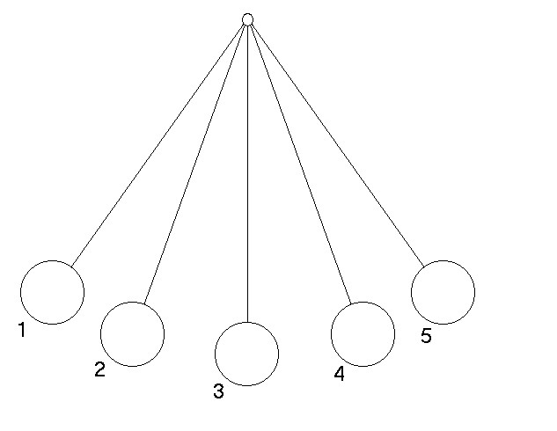
- To the right is a pendulum, swinging back and forth. Describe the amount of potential energy and kinetic energy at each position.

      - 100% PE, 0% KE
      - 50% PE, 50% KE
      - 100% KE, 0% PE
      - 50% PE, 50% KE
      - 100% PE, 0% KE

S8P2 c Forms of Energy

- What are the forms of energy that we have discussed? Explain where the energy comes from and which category the energy fits into.
Potential energy—stored (Potential) (could be gravitational, elastic, or chemical)
Kinetic energy---motion (Kinetic)
Mechanical energy—combination of potential and kinetic energies (Kinetic)
Thermal energy---from motion, friction (Kinetic)
Electrical energy---flow of electrons (Kinetic)
Chemical energy---from chemical reactions (Kinetic)
Nuclear energy---from nucleus of atom (Kinetic)
Electromagnetic energy---from electrical and magnetic interactions (Kinetic)
solar energy---from the sun (Kinetic)

- What two types of energy make up mechanical energy? Potential and Kinetic

- Show with arrows the transformation of energy in the following:
Waterfall’s energy → Potential-Kinetic
Dam----Kinetic- Potential--Mechanical--Electrical
Match Energy → Mechanical-Thermal-Chemical--Thermal-Electromagnetic
  Battery’s Energy → Chemical Potential -Electrical

12. What is the unit for energy? _Joule (j)____

S8P2d Transfer of Energy

- What are the three ways that heat can be transferred? Define each and explain the transfer, including the state of matter that may be involved.
1 Conduction—physical contact between particles; requires a medium

2 Radiation---No physical contact; No medium required; Can transfer through a vacuum (space).

3 Convection---Flows through currents, whether they are gas or liquid (requires a medium)

- Beside each picture show each of the ways heat is transferred (You listed them above). You will need to add to the picture.

Conduction—physically touch Radiation—feel heat through Convection-heat flows
flame or wood to feel heat air—don’t have to touch through current (air currents)

- What is the difference between temperature, thermal energy, and heat?
Temperature is the measure of the amount of thermal energy in an object.

Thermal Energy is the kinetic activity of the particles that make up an object.

Heat is the flow of thermal energy from warmer to cooler temperatures.

- How can a large rock, that is cooler than a small rock, have more thermal energy than the small one?
The greater mass requires more energy to maintain a particular temperature than a smaller mass does.

- What are the three temperature scales? Which is the SI unit?
There are several scales in which to measure temperature: Celsius (metric), Kelvin, and Fahrenheit.

- What is 0 K (Zero Kelvin)?
The temperature at which absolutely NO kinetic activity takes place---not even vibrations.

