Class of 2019

Mission Possible: Graduation and Beyond



High School 101
A Handbook for Students and Parents
Paulding County School District

Supports BRIDGE Advisement Mandates



Please note: The information provided in this guide is subject to change as updates and/or requirements become final from the Georgia Department of Education, Paulding County School Board (policy), and/or the Georgia Student Finance Commission Guidelines.

TABLE OF CONTENTS
Getting Started, Making Choices 3
Mission Possible - Paulding County Counseling and Advisement Program 4
BRIDGE Advisement – Mandated Advisement 5
Suggestions for Parents 7
Academic Success 8
Graduation Requirements 9
Noteworthy for the Class of 2019 12
Important Definitions 13
High School Classes and Grading 15
Extra-curricular Eligibility 15
Advisement and Course Request (BRIDGE Graduation Plan) 16
Advanced Placement and Honors Courses 17
Becoming a Pathway Completer 18
English/Language Arts 19
Mathematics 20
Science 21
Social Studies 22
Electives (course descriptions) 24
Career, Technology and Agricultural Education 26
Career Clusters and Pathways for All High Schools 27
High School Academic Core and Elective Course Offerings Chart 33
Online Course Opportunities 37
Test-out Course Opportunities 38
Career Development 39
Plans of Study 39
Thinking About College 40
College Admissions 41
SAT and ACT 42
HOPE Scholarship 43
Hope Rigor Requirements 44
BRIDGE Advisement and Career Planning 46
Georgia’s HOT Careers to 2020 55
Career Interests – It’s All About YOU 57
Courses, Credits, and Completers 60
College Credit Now for High School Students 62
Work-Based Learning 66
Making a Plan 67
Increase Your Chances for High School Success 68
Helpful Websites 70
Personal/Social Development 71
How Self-Awareness Helps You Learn 71
Just Keep Peace 72
Appendix 73
Freshman Checklist 74
A Successful Transition 75
Getting Started, Making Choices

As students move into high school, they have increasing opportunities to focus on their learning and plan for life after graduation. There are various academic, community, and social activities to be involved with, which provide a wealth of experiences. Get involved, take charge and become the best student you can are three important areas to emphasize as you move into high school. Students make many decisions during this time. Future decisions require careful thought and planning and a collaborative effort among students, parents, counselors and teachers.

This handbook along with the Career Planner located on the main page of the district website is designed to assist the student and parent in making the high school experience both informative and successful. The information outlines graduation requirements, including course requirements for the high school diploma as well as required testing. Additionally, it provides valuable guidance in curriculum choices. Students and parents need to use this information while working closely with school personnel to complete a BRIDGE Advisement Graduation Plan, finalized the spring semester of the eighth year and reviewed annually. This plan includes all four years of high school and includes career decisions and goals after high school. As students complete Section 2 of the Graduation Plan, these courses become their course requests for the 9th grade year. Students are required to select 2 Pathways and the appropriate 3 courses for 3 high school years for each pathway and then, 4 electives in priority order in Section 2 of the BRIDGE Plan.

In a highly competitive and changing society, a quality high school education is essential in offering the academic foundation that students will need to be successful in an increasingly sophisticated and complex global community. Students are encouraged to improve, wherever they are academically, focusing on learning, working at and beyond grade level, and extending learning through enrichment activities. Students are encouraged to select challenging classes and explore career choices throughout high school.

The transition process into high school has already begun. The sixth, seventh, and eighth grade teachers, counselors, and administrators have been preparing students for this important step. BRIDGE advisement career interest inventories and career exploration and research on GACollege411 and classroom guidance activities have been experienced by all middle school students. In addition, eighth grade students have experienced classroom guidance from the high school counselors regarding the high school experience and course offerings. Each middle school offers a graduation plan and course request presentation and work session opportunity during 1st or early 2nd semester. Each high school has an 8th Grade Parent Night in the spring. Counselors are there, at every turn, to see that students are ready and able to get the most out of the quality education offered within Paulding County high schools. Students are encouraged to participate in Freshmen Focus, an orientation opportunity, which is offered at each high school shortly before school begins.

While high school is new and exciting, it is perfectly natural to have some apprehension about the changes. High school is different from middle school due to increased responsibility and academic challenges. Along with the accepted responsibility, come more individual choices and freedoms.

Becoming familiar with the information in this handbook is a good start for a successful high school experience. Students and parents should use this guide and the district Career Planner throughout the high school experience as well as this critical time of beginning high school. Career Planner link:
http://www.paulding.k12.ga.us/content_page2.aspx?cid=2412

Let the journey begin and welcome to high school!

Mission Possible: Graduation and Beyond

Mission Possible: Graduation and Beyond is a district-wide program that places emphasis throughout all grade levels that students and parents/guardians will focus on graduating from high school. In addition, students work collaboratively with school counselors to make certain that academic and career goals are identified and met through annual BRIDGE Advisement opportunities.
Under this initiative, students are referred to as the “Class of ….”. Therefore, your 8th grade student has been and will be referred to as a student in the Class of 2019. All middle school students complete career portfolios using www.GAcollege411.org. In addition to these worthwhile activities, students receive academic support and annual advisement/transition opportunities. Information is provided for students and parents as the student both enters and leaves middle school as well as during high school.
As your student moves to high school, high school counselors also provide academic and career support through major advisement projects, classroom guidance, Reality/Pathway as well as Career Fairs, and an enhanced use of www.GAcollege411.org which includes mandated BRIDGE Advisement requirements. Individual students who need additional support are provided with credit recovery opportunities, individual counseling sessions, and mentoring support. Your high school counselors will implement the counseling program by providing classroom guidance which includes topics in academic skills support; organizational, study and test taking skills; career awareness and planning; and communication, problem-solving, and decision making skills. In addition to classroom guidance, students will be advised in individual student planning. Students along with parents/guardians will have an opportunity to participate in annual major BRIDGE Advisement planning sessions. Additionally, students may meet with a counselor to implement goal setting and complete career plans. Counselors also provide "responsive services" support for non-academic needs through either individual or small-group counseling. Also, high school counselors are intricately involved in the School Improvement Plans, support of testing, and the overall management of the counseling program. High school counselors work collaboratively with parents on academic planning and support, one-on-one parent conferencing, dual enrollment, school-to-work transition programs, and post-secondary planning.

Today’s young people are living in an exciting time, with an increasingly diverse and mobile society, new technologies, and expanding opportunities. To help ensure that they are prepared to become the next generation of workers, leaders, citizens and parents, every student needs support and guidance while exploring opportunities during the high school years, a time of rapid growth and change. Today, young people face unique and diverse challenges, both personally and developmentally, that impact academic achievement. High school counselors do not work in isolation; rather they are integral to the total educational program of all students. They provide proactive leadership that engages all stakeholders in the delivery of programs and services to help the student achieve success in school. Professional school counselors align and work with the school district's mission: Focusing on Learning, to support the academic achievement of all students as they prepare for the ever-changing world of the 21st century.



BRIDGE ADVISEMENT - (Mandated Advisement Grades 6-12)

The following is the BRIDGE Advisement that was signed into law on May 20, 2010 by the Georgia General Assembly. The major advisement projects in the Paulding County School District support the requirements of the BRIDGE Advisement.

BRIDGE ADVISEMENT‐ Section 20‐2‐327 Part (c) ‐ Georgia General Assembly HB 400 (May 20, 2010)
(c) Beginning with the 2010‐2011 school year, students in the sixth, seventh, and eighth grades shall be provided counseling, advisement, career awareness, career interest inventories, and information to assist them in evaluating their academic skills and career interests. Before the end of the second semester of the eighth grade, students shall develop an individual graduation plan in consultation with their parents, guardians, or individuals appointed by the parents or guardians to serve as their designee. High school students shall be provided guidance, advisement, and counseling annually that will enable them to successfully complete their individual graduation plans, preparing them for a seamless transition to postsecondary study, further training, or employment. An individual graduation plan shall:
(1) Include rigorous academic core subjects and focused course work in mathematics and science or in humanities, fine arts, and foreign language or sequenced career pathway course work (Federal Perkins Program of Study (POS)
(2) Incorporate provisions of a student's Individualized Education Program (IE), where applicable;
(3) Align educational and broad career goals and a student's course of study;
(4) Be based on the student's selected academic and career focus area as approved by the student's parent or guardian;
(5) Include experience based, career oriented learning experiences which may include, but not be limited to, internships, apprenticeships, mentoring, co‐op education, and service learning;
(6) Include opportunities for postsecondary studies through articulation, dual enrollment, and joint enrollment;
(7) Be flexible to allow change in the course of study but be sufficiently structured to meet graduation requirements and qualify the student for admission to postsecondary education; and
(8) Be approved by the student and the student's parent or guardian with guidance from the student's school counselor or teacher adviser.
An individual graduation plan shall be reviewed annually, and revised, if appropriate, upon approval by the student and the student's parent or guardian with guidance from the student's school counselor or teacher adviser. An individual graduation plan may be changed at any time throughout a student's high school career upon approval.

Middle School

- The following BRIDGE Law Advisement tasks are required to be completed in middle school in the student’s My411, GACollege411 portfolio:
  - Grade 6
    - My411 Account must be set up
Account/User Name: PCSDXXXXX (XXXXX=5 digit student number)
Password: mmddyyyy (birth date only unless does not work, then add first, middle and last name initials)
Very Important: Student must not change user name and password without contacting school counselor.

Interest Profiler Career Interest Inventory must be completed.
  - Grade 7
    - Career Cluster Inventory must be completed.
    - 3 Career Concentrations/Clusters must be explored.

  - Grade 8
    - 3 Careers and Occupational Information must be saved on 3 careers in the student’s portfolio.
    - Individual Graduation Plan is input on the Graduation Plan/Plan of Study from the district BRIDGE Law Advisement Plan document
    - “College Credit Now”/Dual Enrollment Information is provided.

High School

- The following BRIDGE Advisement tasks are required to be completed in high school in the student’s My411, GACollege411 portfolio:
  - Grade 9
    - GACollege411 BRIDGE Advisement Graduation Plan (IGP) must be created or updated.
    - “College Credit Now”/Dual Enrollment Information is provided.
    - Three careers are explored which may be the same or different than the careers explored during eighth grade.
  - Grade 10
    - GACollege411 BRIDGE Advisement Graduation Plan (IGP) must be updated.
    - “College Credit Now”/Dual Enrollment Guideway is completed on GACollege411.
  - Grade 11
    - GACollege411 BRIDGE Advisement Graduation Plan (IGP) must be updated.
    - 3 Postsecondary Institutions related to student’s Plan of Study are explored.
  - Grade 12
    - Senior Letter is received and reviewed by all students and parents.
    - Students identify and submit “next step” information: 4-year institute, 2-year institute, apprenticeship, military, technical college, special purpose school, or workforce in GaCollege411.

SUGGESTIONS FOR PARENTS

- Review this guide and the district Career Planner.
- Review the choices that your student has made in eighth grade about what classes he or she will take in the ninth grade and attend the BRIDGE advisement opportunity held at the middle school that focuses on high school registration and planning. Seek the help of school counselors, if you have questions.
- Review the BRIDGE Advisement Graduation Plan document with your student. This is completed during the 1st semester or early 2nd semester advisement opportunity at the middle schools.
- Get involved with your student’s teachers and attend school functions.
- Encourage your student to become involved in the school community.
- Understand that it may take your student several weeks or months to get used to high school.
- Continue to encourage your student to be responsible and make good choices.
- Make sure teachers have correct phone numbers and email addresses for communication purposes.
- Review the high school student handbook that is given out each fall.
- Use Infinite Campus to continually review grades.
- Use the Paulding County School District website to review calendar, testing, academic, and athletic/extra-curricular information.
- Utilize the local high school website for communication, upcoming events, and important information.

Career Planner

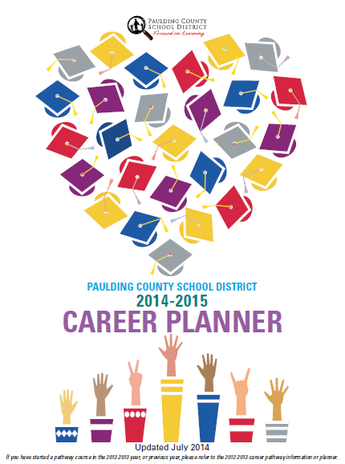

ACADEMIC SUCCESS

This section will focus on the standards that will help you be successful in high school—mastering standards in your courses, earning credits and graduating in four years. You will also learn about your options for continuing your education beyond high school.

School counselors will help you with:
Standard A: Students will acquire the attitudes, knowledge and skills that contribute to effective learning in school and across the life span.
Standard B: Students will complete school with the academic preparation essential to choose from a wide range of substantial postsecondary options, including college.
Standard C: Students will understand the relationship of academics to the world of work and to life at home and in the community.
(Source: The American School Counselor Association National Model)

ACADEMIC EXPECTATIONS

For your student to be successful in high school, ensure that your student does the following:
- Attends class every day—Be in all classes every day! Studies show us that students perform better when they are actively engaged in instruction.
- Brings all materials to class—Always be prepared and take proper materials with you to class. A builder does not go out to his job without a hammer, nails, lumber, and numerous tools. You are building your educational background for your future; so you need your tools to do the job!
- Completes work on time—Keep up with all assignments and turn in projects. Being reliable and prompt will impress teachers as well as peers.
- Demonstrates personal organizational skills, such as record keeping, time-management, homework habits, note-taking skills, and listening skills.
Develop these areas to be successful in your education:
- Seek help from your teachers early when there is something that you do not understand.
- Use and improve both oral and written communication skills.
- Read additional books to enhance and supplement vocabulary.
- Apply knowledge to new situations.
- Increase research skills.
- Improve basic keyboarding skills.
- Strengthen math skills—the ability to work fractions, percentage, decimals, algebra, geometry and averaging problems.
- Review all materials thoroughly as you prepare for an assessment or project.

ACADEMIC STUDY SKILLS
This section will focus on the standards that will help you be successful in high school—mastering HOW
TO STUDY AND ACHIEVE ACADEMIC SUCCESS
Study Plan and Study Preparation
Find a good place to study which eliminates all distractions, has good lighting, and all books and notes that you need. In your study plan identify and know your daily study schedule, what you need to study, review and recall key points, and review notes taken in class.
Review Techniques
Plan enough to allow an adequate review before all tests. Summarize your notes. Predict what you may be asked on a test.

Attitude
Think of learning as an opportunity to increase your knowledge and skills. Think of tests as a way to show yourself what you know, and what you don’t know.
Organize
Plan to study and review on an ongoing basis. This will help you stay calm for tests.
Pace Yourself
When you are completing a test or project, carefully read the instructions. If a rubric is involved, ask questions until you understand the rubric. Budget your time well, particularly when you are taking an in class assessment. Always reread and check your work.

LISTENING SKILLS AND ACADEMIC SUCCESS
Stay Focused and Listen
Listening is one of the most important skills you can develop. It is the second most difficult skill next to reading. Listening means no daydreaming and forming good habits of really hearing and not talking.
Predict What You Will Learn
Think about the main points of the last class and review any reading, problems, or other work that you have been assigned.
Keep It Relevant
What did the assignment have to do with your class? What comes to mind during instruction? Do you have enough background knowledge about what you are trying to learn? Can you connect this knowledge to future learning, i.e. math problem solving helps you with life problem solving skills?
Learning to Listen
Do not confuse hearing with listening. Good listening means paying attention as well as thinking about and around the topic. Listening is an active, not passive, activity.

TIME MANAGEMENT

Success in school depends on how well you plan your time. While in high school, always think about balancing your time. Of course, you need time to attend class and study. However, you will also take time to participate in sports, band, other extracurricular activities, etc. You also need time to enjoy. Remember exercise reduces stress! Take some time to reward yourself and do something special.

GRADUATION AND PROMOTION REQUIREMENTS

Plan of Study

For the Class of 2019, there is one plan of study that leads to a high school diploma in Georgia. However, the individual plans of study information linked to a Career Cluster and Pathway or Advanced Academic, Fine Arts or World Language Pathway are designated in this guide as well as the Career Planner. A plan/program of study is the set of courses needed to complete the requirements for graduation.

The chart on the next page lists how many units of credit are needed in each course area in order to complete the graduation requirements and earn a high school diploma. This information is also located on the BRIDGE Advisement Graduation Plan in the left column.

High School Diploma Requirements
Areas of Study | Units of Credit |  | Addtl. Information
English/Language Arts*** | 4 units
Mathematics*** | 4 units
Science*** | 4 units
Social Studies*** | 3 units
Health and Physical Education | 1 unit
CTAE and/or World Language and/or Fine Arts | 3 units |  | 2 units of the  same World  Language for admission to colleges and universities
General Electives | 4 units
Total Units Required for Graduation | 23 units
***Research, Regional, and State institutions of The University System of Georgia may require additional units in academic core areas in addition to the high school diploma units required.

The following provides the total unit requirements for graduation and the unit requirements for promotion into the next grade level.
Graduation Requirements | 23 units
Promotion Requirements | To 10th – 5 units  To 11th – 11 units  To 12th – 17 units

GEORGIA GRADUATION RULE - (The IHF6 Graduation Rule Began with Class of 2012)

Please note: The Georgia State Board of Education implemented the current IHF6 Graduation Rule beginning with the Class of 2012. The information provided in this guide on the questions and answers as well as the high school diploma chart with required units and the student’s BRIDGE Graduation Plan document are based on the rule that is currently in place for all high school students in grades 9-12. It is not anticipated at this time that there will be any graduation rule changes, however, all the information in this guide is subject to change as rules and requirements are mandated from the Georgia State Board of Education.

On the next page are the graduation requirements for students who are in 9th, 10th, 11th, and 12th grades during the 2014-2015 school year. The Class of 2019 students will have the same requirements as the last column on the right of the chart indicates. Former EOCTs will now be End of Course Assessments.

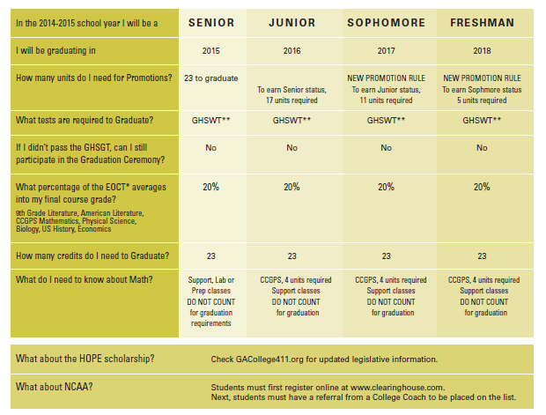

State Board Passed Graduation Rule for Class of 2012 and Thereafter
In an effort to establish high expectations for all students, the State Board of Education passed a set of graduation requirements in September 2007. The IHF6 rule and BRIDGE Advisement emphasizes the importance of a single diploma choice and counselors supporting students through BRIDGE advisement planning.
Q: What classes of students are under the IHF6 rule?
A: IHF6 = Classes of 2012, 2013, 2014, 2015, 2016, 2017, 2018 and 2019 students

Q: Why did Georgia decide to revise the graduation rule(s)?
A: IHF6: The Georgia State Board of Education determined that a new set of graduation requirements were needed to assure that Georgia’s high school graduates are college and work ready.

Q: Any addition reasons as to why the rules changed?
A: IHF6: The Class of 2012 rule was revised in conjunction with the implementation of the new Georgia Performance Standards in English/language arts, mathematics, science, and social studies as well as in some electives.

Q: What did the Class of 2012 (IHF6) rule do for our students?
A: IHF6: The rule eliminated Georgia’s “tiered” diploma, in which there were different expectations for different students with four diploma options. All students now receive a strong core of classes in English/language arts, mathematics, social studies, and science. Elective courses are used to personalize the educational experience and to focus on the student’s career interest area.

Q: Who did the rule affect?
A: IHF6: Since the Class of 2012 graduation rule officially went into effect during the 2008-2009 school year, the requirements affect those students who are currently in high school. It is also important to note:
- Currently, during the 14-15 school year, there are three courses in our district that count for high school credit while being taken at the middle school level for eighth grade students. These courses are 9th Grade Honors Literature and Composition, CCGPS Honors Coordinate Algebra and Spanish I. These courses will count in the student’s high school GPA and will be recorded on the high school transcript.
- Per state legislation (beginning with the Senior Class of 2007), high school courses taken in middle school do not count toward the HOPE Scholarship grade point average.

Q: What are the major changes in the graduation rule?
A: IHF6: The Class of 2012 & Thereafter graduation rule requires that all students have 23 credits to receive a diploma, including:
• Four credits in English/Language Arts
• Four credits in Mathematics
• Four credits in Science
• One credit in Health/Physical Education
• Three credits in World Language** and/or Fine Arts and/or Career, Technical and
Agricultural Education (CTAE)***
• Four electives
** Any student going to a University System of Georgia college or university must take at least two years of the same World language to meet admission requirements.
*** Students wishing to receive industry certification in certain areas under Career, Technical and Agricultural
Education programs must follow specific pathways and take three sequential courses in the same pathway. Certification tests are completed during the spring semester of the 3rd Career Pathway course.

Q: What about students who receive special education services?
A: IHF6: Students with disabilities will be eligible to earn a regular diploma following specific criteria as outlined in the graduation rule.

Q: Is the Paulding County School District required to abide by the graduation rules?
A: IHF6: Yes. All Georgia public school systems are required to implement the graduation rule.

NOTEWORTHY FOR THE CLASS OF 2019

Advisement-Thinkgate Parent Portal
Parents/guardians may review the advisement checklists in the Thinkgate Parent Portal. These checklists begin in 8th grade, and there are checklists as well in grades 9-12. This information includes what students are completing at school as well as provides links to a variety of sources about careers, colleges, technical colleges, scholarships financial aid, etc. Sample October Checklist for Students is below. Student checklists for 8th and 9th grades are included in this guide. Parent checklists are available on the Thinkgate Parent Portal.

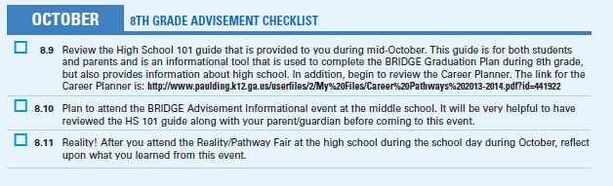

BRIDGE Advisement/Parent Conferences and Teacher/Parent Conferences:
Both parents and students will participate in conferencing opportunities each year. Specific sessions for parents and students will be conducted to plan, review, and/or revise progress toward the student’s diploma requirements and career pathway/focused area of study choice. The BRIDGE Advisement Graduation Plan will be completed in 8th grade and reviewed annually. Conferences with subject area teachers regarding individual courses may be scheduled as needed with the individual teachers.

GAcollege411.org: www.GAcollege411.org is an online, interactive tool that helps students make choices about careers, colleges, technical schools, and financial aid. This site is used for each student to complete all of the BRIDGE Law mandated activities and save in the student’s individual portfolio. It is a resource to help students and their families select a college, apply for admission, and plan to finance higher education. The mission of GAcollege411 is to: 1) increase access to postsecondary education in the state of Georgia and, 2) simplify the tasks and processes related to planning, applying and paying for higher education. GAcollege411 offers access to comprehensive information about colleges, universities, and technical colleges in Georgia. The site also enables students to apply for admission to each school listed. Students build their portfolio using this website. NOTE: Seniors request high school transcripts to be sent to in state schools (technical college and college) via their GAcollege411 account.

HOPE Scholarship:
The HOPE scholarship is a unique opportunity for Georgia high school students. Because the State continues to toughen the standards and requirements for obtaining this scholarship, parents and students should check Georgia Student Finance Commission’s website often (www.gsfc.org/HOPE/index.cfm) for the most current information. Every student must have his/her legal name, social security number, and correct birth date to be eligible for the HOPE Scholarship. Students should continually monitor the HOPE gpa on their My411 account.

Infinite Campus Viewer:
Both parents and students can monitor academic progress, check for missing assignments, and review attendance information through the Infinite Campus Viewer. Teachers enter grades and attendance into their electronic grade book, and Infinite Campus organizes and formats the data for convenient viewing at any time of the day or night. A student ID number and PIN code are required for access. The IC Viewer can be accessed from the main page of the Paulding County School District website. As with other online services, there may be times that the server is unavailable. In that case, please check back later.

Mathematics Placement:
Mathematics placement for the upcoming ninth grade class will be based on a number of factors. Factors considered will include the most recent middle school Milestone assessments or other state-mandated standardized test scores as well as the level of performance in the mathematics class in which the student is currently enrolled. Students taking CCGPS Honors Coordinate Algebra in eighth grade will take CCGPS Honors Analytic Geometry in ninth grade.

Participation in Graduation Ceremonies:
Only students who have met graduation requirements for a diploma as established by Board Policy IHF-HIGH SCHOOL GRADUATION REQUIREMENTS, will be allowed to participate in graduation ceremonies. Students will be required to perform with a passing score on the appropriate state graduation assessment and attain at least twenty-three (23) Carnegie units of credit before participating in the high school graduation ceremonies. Special needs students will continue to follow their Individualized Education Program (IEP) to determine graduation status.

Reality/Pathway Fair:
Eighth grade students attend a Reality Fair at one of the five high schools. Students receive a beginning salary that is linked to their chosen career. Then, students rotate through several booths: housing, daycare, car, groceries, city hall, furniture, insurance, clothing, charity, entertainment, life’s unexpected event, etc. to see how far a month salary goes for their monthly expenses. In addition students have an opportunity to visit different booths to gain knowledge about the Career Technical and Agricultural Education (CTAE) Pathway courses offered at the high school along with information about the corresponding Career Technical Student Organization. This information helps students to select a CTAE Pathway.


IMPORTANT DEFINITIONS

Carnegie Unit: High school courses are set as a 100-minute course earning
1.0 credit at the end of the semester or as a 50-minute course carrying ½ unit
of credit at the end of a semester. A student earns either one or ½ unit of credit
in December and one or ½ unit of credit in May for each course if he/she has a
passing grade (70 or above). Students are scheduled with the possibility of earning
a minimum of 7 Carnegie units of credit per school year with three and ½ credits earned in the fall semester and three and ½ credits earned during the spring semester.

Core Courses: Courses from English, Mathematics, Science, Social Studies and World Language. For industry certification in the Career, Technical and Agricultural Education area three courses in the same area are considered core. In addition, for a student to complete a CTAE Career Pathway the courses must be taken in sequence and completed within the pathway. An End-of-Pathway Assessment is given at the end of the third CTAE sequential course.

Elective Courses: Courses that a student may select beyond the core requirements to fulfill the total Carnegie unit requirements for graduation.

End-of-Course Milestones Tests: End-of-Course assessments are mandated for CCGPS Algebra and CCGPS Geometry as well as the accelerated levels of these two courses. In addition regular and honors courses in these areas have EOCs: Ninth Grade Literature/Composition, American Literature/Composition, Biology, Physical Science, U.S. History, and Economics. Students enrolled in these classes will be required to take these tests to earn credit. Student’s scores will count as a percentage determined by the State Department of Education and will be the final exams for the courses. Currently, the percentage weight is 20 for the EOCs. To earn credit the student’s final grade for the course must be an average of 70. These tests are also used if a student opts to test-out of any of the EOCT courses. See Test-out section for more information.

Grading Period: The high school grading period is 18 weeks or one semester. Thus, the fall semester grading period begins in August and continues to build until the end of the first semester. Then, the spring semester grading period begins in January and continues until the end of school. Only classes which are specifically designed to be semester in length (i.e. economics, government, personal fitness, health) will be completed at the end of one semester and therefore, a second course/semester is not required.

High School Diploma: Document awarded to students certifying that they have satisfied requirements of attendance, Carnegie units, and testing as specified by the State of Georgia and local Board of Education, including the specified Georgia High School Graduation Writing Test and End-of-Course grades that include the course grade and test calculation.

PSAT: Historically, the PSAT assessment is given in mid-October to all 10th grade students in the state of Georgia. Eleventh grade students take this test to meet qualifications for the National Merit Scholarship.

Prerequisite Courses: courses that must be passed in order to enroll in the next or subsequent course in a subject area.

Promotion: For a 9th grader to move to 10th grade status, he/she must earn a minimum of 5 Carnegie units.

Required Courses: Specific courses or their equivalent which must be taken and passed in order to graduate and receive a diploma.

Transcript: A written record of a student’s academic progress toward a diploma.

HIGH SCHOOL CLASSES AND GRADING

- The school year is divided into 2 semesters of approximately 18 weeks each. Middle school students who have taken the Honors 9th Grade English/Lit and/or CCGPS Coordinate Algebra courses also have grades posted at the end of each semester with .5 credit earned for passing the course with a 70 or higher.
- A student takes a minimum of 7 credits of courses each year for four years.
- Taking 7 classes, a student can earn 7 units of credit per year if all classes are passed.
- Generally, a freshman takes 4 or 5 core courses including one in each area of English, Math, Science, and Social Studies. Most 9th graders also take Health/Personal Fitness during the 9th grade year with the other class usually being an elective. Some students begin or continue their World Language requirement during the 9th grade year. World Language (Modern Language/Foreign Language) is considered a core course. Students must graduate with two courses in the same World Language in order to be admitted to a college or university. World Geography, if taken, is a Social Studies elective course.
- Ninth grade core courses are one credit courses with grades and credits finalized at the end of first semester and then, again, at the end of second semester. Some core and elective courses are taught on a 100-minute block with one full credit earned at the end of the semester. For a traditional course, .5 credit is earned at the close of first and then, .5 credit is earned at the end of second semester. Both first and second semester grades and credits are a part of the permanent record and transcript. For semester courses, i.e. Health and Personal Fitness, semester grades and credits are earned either at the end of first or second semester. For each course, a percentage of the final grade is determined by a cumulative exam or for EOC courses, the EOC grade.
- The overall grade for the course determines whether or not credit is awarded. A final grade of ‘70’ or better is required for passing and earning credit for a course.
- If a student fails any required course, the student must repeat the class until it is passed. A failing grade remains on the academic record and is included in the student’s overall Grade Point Average (GPA). If a student fails a required class, the student must make immediate plans to retake the class. Summer school, night school, online courses, and Georgia Virtual Credit Recovery are the best routes to follow for credit recovery. Credit recovery information is available through school counselors.

- A total of 5 units must be passed in order to become a 10th grader.
- Individual teachers will provide a course syllabus with an outline of the course, classroom expectations and a grading plan. Performance standards are provided by each teacher.

HIGH SCHOOL GRADING SCALE

90 – 100 A
80 – 89 B
70 – 79 C
Below 70 F



“EXTRA-CURRICULAR” ELIGIBILITY

Eligibility refers to a student’s good standing so that he/she may participate in high school athletics and other competitive activities, which includes cheerleading. Eligibility rules are governed by the Georgia High School Association (GHSA). Currently, all first time 9th graders are eligible to participate for the first semester. To maintain eligibility for second semester, a 9th grader must be passing at least five (5) of his or her classes and “be on track for graduation” (GHSA). Second-year students must have accumulated five (5) total Carnegie units in the first year, and passed at least five courses in the previous semester.

According to GHSA rules, students must reside in the local school’s attendance area as established by the Board of Education. Students attending a school outside their home school’s attendance zone must sit out for one year before becoming eligible.

Please note: A student can have no more than five unexcused absences in the prior semester in order to participate in extra-curricular activities.

ADVISEMENT AND COURSE REQUEST COLUMN (S.2) FOR 9TH GRADE COURSES

The following is the BRIDGE Advisement Graduation Plan Document (page 1). Please note Section 2 for making course requests for the 9th grade year (2014-2015). Course descriptions are in this guide and are also in the district’s Career Planner.

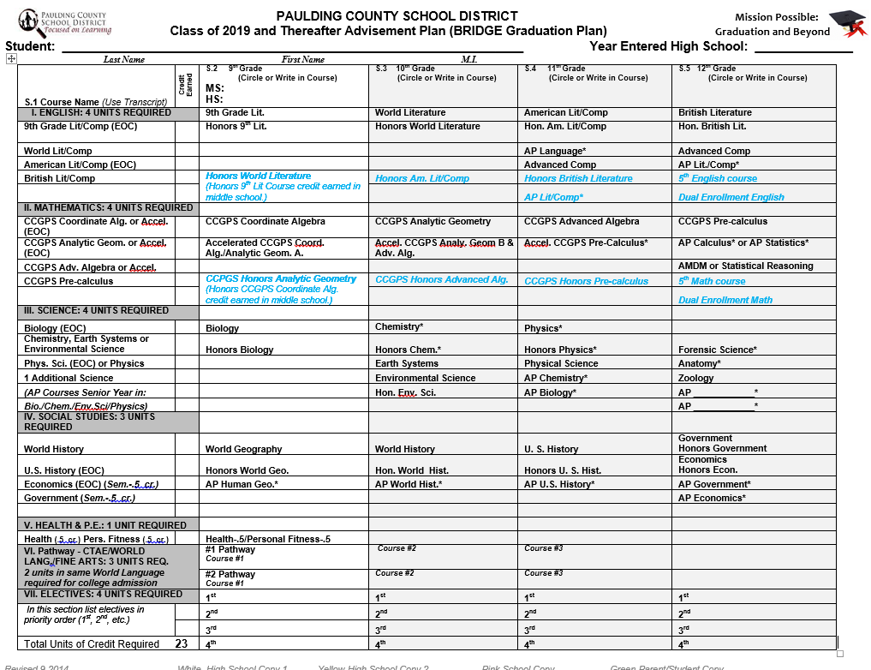

Link for Career Planner with advisement information and course descriptions for all grade levels:
http://www.paulding.k12.ga.us/userfiles/2/my%20files/ctae/pcsd%20career%20planner%20book%202014-2015%20v2.pdf?id=538431

ADVANCED PLACEMENT AND HONORS COURSES

In order to make an informed decision about taking an AP or Honors course, the following needs to be considered:
General Questions to Consider:
- How many other commitments does the student have before or after school with athletics, work, clubs and activities, etc?
- How many other AP and/or Honors courses will the student be taking at the same time?
- Is the student willing to make a commitment since schedule changes may not be feasible once school begins?
- Is the student willing to work during the summer on assignments and/or reading which may be assigned?
- Is the student comfortable with extensive amounts of reading and writing required for each of the courses?

Advanced Placement Information
To make an informed decision about an AP course, it is helpful to read the syllabus and content before making a commitment. The College Board (which administers the AP exam and sets course content) has a webpage with links to syllabi for each of the AP courses in addition to parent and student bulletins, helpful information, etc.:
http://www.collegeboard.com/student/testing/ap/about.html.
As long as a student earns a grade of 70 or above, 10 points are added to the student’s average in the course (at the end). With HOPE scholarship calculations, AP courses receive a .5 weighting on a 4.0 scale which is added by the Georgia Student Finance Commission. (Note: This differs from the 10 points added for Advanced Placement courses on the Paulding County School District official transcripts. GSFC removes the 10 points and then, adds the .5 on the 4.0 scale for AP courses. The highest gpa that GSFC awards for an A is a 4.0. No weighting is added on the Georgia Student Finance Commission HOPE transcript for honors courses.) As long as a student scores well enough on the AP exam administered in the spring each year, they can possibly earn college credit for this course.

Honors Course Information
Honors courses follow the same Georgia Performance Standards (GPS) as non-honors courses, however, the content is studied at a much deeper level and it is often at a quicker pace than in a non-honors course. As long as a student earns a grade of 70 or above, 5 points are added to the student’s average in the course (at the end). With HOPE scholarship calculations for an honors course, however, zero points will be added to their average.

Important: Course Requests for All Grade Levels are completed during the IC Registration Process
Advanced Placement and Honors course requests require parent approval. For 8th grade students the BRIDGE Advisement Graduation document has a parent signature line on page 2. This signature approves all Section 2 (page 1) courses including AP/Honors courses for the ninth grade year.

BECOMING A PATHWAY COMPLETER DURING HIGH SCHOOL

In order for high school students to become a pathway completer the following four areas should be considered. Students are strongly encouraged to complete one pathway from these areas:
- CTAE Pathway: a series of 3 or 4 specified courses in a CTAE-approved pathway. Review the 14-15 Career Planner for Cluster and Pathway information.
- Advanced Academic Pathway: an Advanced Academic Pathway may be followed in any of these four content areas: English Language Arts (ELA), mathematics, science or social studies. A student has completed an Advanced Academic Pathway in ELA, mathematics, science, or social studies when the criteria described in one of these areas below has been met:
  - ELA
Student graduated, thereby completing 4 required credits in ELA, AND Student’s course history in ELA (23 course codes) includes at least one AP* Course Code (23. 043; 23.053; 23.065) or one IB* Course Code (23.06800; 23.06900; 23.06110; 23.06120; 23.06130) or one post secondary enrollment code in 23 that fulfills a core graduation requirement in ELA, AND Student earned credits in two sequential courses in one world language.
  - Mathematics
Student graduated, thereby completing 4 required credits in mathematics, AND
Student’s course history in mathematics (27 course codes) includes at least one AP* Course Code (27.072; 27.073; 27.074) or one IB* Course Code (27.06120; 27.06130; 27.05220; 27.05240) or one post secondary enrollment code in 27 that fulfills a core graduation requirement in Mathematics, AND Student earned credits in two sequential courses in one world language.
  - Science
Student graduated, thereby completing 4 required credits in science, AND
Student’s course history in science (26 course codes and 40 course codes) includes at least one AP* Course Code (26.014; 26.062; 40.053; 40.083; 40.0841; 40.0842) or one IB* Course Code (26.01800; 26.01900; 26.06300; 40.08500; 40.08600) or one post secondary enrollment code in 26 or 40 that fulfills a core graduation requirement in Science, AND Student earned credits in two sequential courses in one world language.
  - Social Studies
Student graduated, thereby completing 3 required credits in social studies, AND
Student’s course history in social studies (45 course codes) includes at least one AP* Course Code (45.016; 45.052; 45.053; 45.062 45.063; 45.077; 45.0811; 45.082; 45.084) or one IB* Course Code (45.01310; 45.01320; 45.01700; 45.017100; 45.06500; 45.06600; 45.07800; 45.07900; 45.08700; 45.08800; 45.08900) or one post secondary enrollment code in 45 that fulfills a core graduation requirement in Social Studies, AND Student earned credits in two sequential courses in one world language.
- Fine Arts Pathway: A Fine Arts Pathway may be followed in any of these five areas of study: visual arts, theater, dance, music, or journalism. A student has completed a Fine Arts Pathway when three courses are successfully finished from those identified in any one of the five areas.
- World Language Pathway: A World Language Pathway may be followed in any of the world language areas included in the state list of approved courses.
Student graduated, AND also, student’s course history in one world language includes 3 distinct high school Course Codes OR includes at least 2 distinct Course Codes plus a third code reflecting an AP* course, where AP courses are offered (60.017, French; 60.077, Spanish; 60.078, Spanish Lit; 61.017, German; 61.047, Latin; 62.0196, Chinese; 63.039. Japanese); or a third code reflecting an IB* course, where courses are offered (French,60.01120, 60.01130; Spanish, 60.07130, 60.07160; German, 61.01120, 61.01130; Latin, 61.04120, 61.04130; Chinese, 62.01900, 62.01910; Japanese, 62.03920, 62.03930; Arabic, 63.10700, 63.01800;) or one post secondary enrollment course code in the same World Language reflecting a third course at the college level.


ENGLISH/LANGUAGE ARTS

Class of 2019 (one diploma—4 units required)
High School English Courses Started in 9th Grade

GRADE 9 | GRADE 10 | GRADE 11 | GRADE 12
Course required for graduation |  | Course required for graduation
9th Literature/Composition  9th Lit/Comp – Honors | World Lit/Composition  World Lit/Composition - Honors | American Lit/Comp  American Lit/Comp – Honors  AP English Language/Comp | English Lit/Composition  AP Lit/Composition
NOTE: All students are required to pass a full year of 9th Literature/and Composition and American Literature/Composition
AND to take the End-of-Course assessment for 9th Literature/and Composition and American Literature/Composition

Ninth Grade Literature/and Composition
23.06100
This course integrates writing, grammar and usage, literature, speaking, listening, and critical thinking skills. In the course, the writing process is presented: planning, drafting, revising, editing, and proofing as well as the study of form in personal narratives, descriptions, and expository papers with an emphasis on persuasive writing. Also, this course includes reading a variety of multicultural literature: short stories, novels, tales, poetry, mythology, characteristics of various genres, literary elements, and vocabulary study.
A state mandated End of Course assessment is required and a percentage of the test counts for the student’s overall course grade.

Ninth Grade Literature/and Composition (Honors)
23.061001
This course integrates writing, grammar and usage, literature, speaking, listening, and critical thinking skills. In the course, the writing process is presented: planning, drafting, revising, editing, and proofing as well as the study of form in personal narratives, descriptions, and expository papers with an emphasis on persuasive writing. Also, this course includes reading a variety of multicultural literature: short stories, novels, tales, poetry, mythology, characteristics of various genres, literary elements, and vocabulary study. Other topics and instructional methods specific to preparing students for the rigors of future honors or AP English courses are also included.
A state mandated End of Course assessment is required and counts as a percentage (percentage currently under review by State Department of Education) of the student’s overall course grade.

English courses emphasize all areas of language arts. In accordance with the state’s curriculum and performance standards, grammar is incorporated into all phases of the English/Language Arts curriculum. English/Language Arts skills, including reading, are foundations to success in high school.

All students are required to complete 4 units of English including one full credit of 9th Grade Literature/and Composition and one full credit of American Literature/Composition.

End-of-Course Milestone Assessments
Students enrolled in Ninth Grade Literature and Composition or Ninth Grade Literature and Composition (Honors) are required to take the state-mandated End-of-Course assessment for that course.

Class of 2019 (one diploma—4 units required)
High School English Courses Started in 8th Grade

GRADE 8 | GRADE 9 | GRADE 10 | GRADE 11 | GRADE 12
Course required for graduation |  | Course required for graduation
Ninth Grade Lit. and Composition Honors | World Lit/Composition - Honors | American Lit/Comp – Honors  AP English Language/Comp | British Lit/Composition  AP Lit/Composition | 5th English Course  Dual Enrollment Course
NOTE: All students are required to pass a full year of 9th Literature/and Composition and American Literature/Composition
AND to take the End-of-Course assessment for 9th Literature/and Composition and American Literature/Composition

Grade 12 Courses in English are optional and may include an English Dual Enrollment Course.

HONORS WORLD LITERATURE/AND COMPOSITION
This course focuses on a study of literary genres; the student develops understanding that theme is what relates literature to life and that themes are recurring in the literary world. The students explore the effect of themes in regard to interpretation. The students will read across the curriculum to develop academic and personal interests in different subjects. While the focus is persuasive writing in tenth grade literature, the student will also demonstrate competency in a variety of writing genres: narrative, expository, and technical. The student will engage in research, timed writings, and the writing process. Instruction in language conventions will occur within the context of reading, writing, and speaking, rather than in isolation. The students demonstrate an understanding of listening, speaking, and viewing skills for a variety of purposes. Other topics and instructional methods specific to preparing students for the rigors of future honors or AP English courses are also included. Summer assignments may be required.


MATHEMATICS

As students embark on their high school careers, they should carefully select their mathematics courses considering the level of skills they have achieved in middle school. This decision should consider their future goals, which could be greatly influenced by the math courses that they are able to complete during their high school career. In most instances, the skills learned in their math classes are a prerequisite for the next course. Therefore, it is necessary for students entering 9th grade to begin at an appropriate level, and to pass their math class each year in order to remain on target for graduation.

Class of 2019 (one diploma—4 units required)
High School Mathematics Courses Started in 9th Grade
The Georgia Mathematics Curriculum focuses on actively engaging students in the development of mathematical understanding. Thus, class of 2019 students will either follow a regular CCGPS series of four math courses or the accelerated math courses ending with an Advanced Placement course plan. Please note that students who need support in math may be required to take support math courses.

GRADE 9 | GRADE 10 | GRADE 11 | GRADE 12
CCGPS Coordinate Algebra* | CCGPS Analytic Geometry* | CCGPS Advanced Algebra | CCGPS Pre-Calculus
Accelerated CCGPS Coordinate Algebra/Analytic Geometry A | Accelerated CCGPS Analytic Geometry B/Advanced Algebra | CCGPS Accelerated  Pre-Calculus | AP Calculus AB or BC or another advanced math course
*A mathematics support class may be required for students who need additional time during the school day in mathematics.

End-of-Course Milestone Assessments
Students enrolled in certain courses will be required to take an End-of-Course Milestone assessments as mandated by the state. This testing will impact students enrolled in the first two math courses as well as the first two accelerated math courses.

CCGPS Coordinate Algebra Prerequisite: Successful completion of 8th Grade Mathematics.
27.09710
- This is the first in a sequence of three high school courses designed to ensure career and college readiness. The course represents a discrete study of algebra with correlated statistics applications and a bridge to the second course through coordinate geometric topics.
- The course requires that students:
- Reason quantitatively and use units to solve problems
- Interpret the structure of expressions
- Create linear and exponential equations that describe numbers or relationships
- Understand solving equations as a process of reasoning and explain the reasoning
- Solve equations and inequalities in one variable and systems of linear equations
- Represent and solve equations and inequalities graphically
- Understand the concept of a function and use function notation
- Interpret functions that arise in applications in terms of the context
- Analyze linear and exponential functions using different representations
- Build a function that models a relationship between two quantities and new functions from existing functions
- Construct and compare linear and exponential models and solve problems
- Interpret expressions for functions in terms of the situation they model
- Experiment with transformations in the plane
- Use coordinates to prove simple geometric theorems algebraically
- Summarize, represent, and interpret data on a single count or measurement variable and on two categorical and quantitative variables
- Interpret linear models

Accelerated CCGPS Coordinate Algebra/Analytic Geometry A
Prerequisite: Successful completion of 8th Grade Mathematics.
27.09750
This is the first in a sequence of mathematics courses designed to ensure that students are prepared to take higher‐level mathematics courses during their high school career, including Advanced Placement Calculus AB, Advanced Placement Calculus BC, and Advanced Placement Statistics. The course requires that students:
- Reason quantitatively and use units to solve problems
- Interpret the structure of expressions
- Create linear and exponential equations that describe numbers or relationships
- Understand solving equations as a process of reasoning and explain the reasoning
- Solve equations and inequalities in one variable and systems of linear equations
- Represent and solve equations and inequalities graphically
- Understand the concept of a function and use function notation
- Interpret functions that arise in applications in terms of the context
- Analyze functions using different representations
- Build a function that models a relationship between two quantities and new functions from existing functions
- Construct and compare linear and exponential models and solve problems
- Interpret expressions for functions in terms of the situation they model
- Experiment with transformations in the plane
- Use coordinates to prove simple geometric theorems algebraically
- Understand congruence in terms of rigid motions
- Prove geometric theorems
- Make geometric constructions
- Understand similarity in terms of similarity transformations and prove theorems involving similarity
- Define trigonometric ratios and solve problems involving right triangles
- Understand and apply theorems about circles; find arc lengths and areas of sectors of circles
- Explain volume formulas and use them to solve problems
- Summarize, represent, and interpret data on a single count or measurement variable and on two categorical and quantitative variables
- Interpret linear models

Class of 2019 (one diploma—4 units required)
High School Mathematics Courses Started in 8th Grade

GRADE 8 | GRADE 9 | GRADE 10 | GRADE 11 | GRADE 12
Honors CCGPS Coordinate Algebra* | Honors CCGPS Analytic Geometry* | Honors CCGPS Advanced Algebra | Honors CCGPS Pre-Calculus | 5th Math Course  Dual Enrollment Math Course

Grade 12 Courses in Mathematics may include AP Calculus, AP Statistics and/or may include a Mathematics Dual Enrollment Course.

27.09720
CCGPS ANALYTIC GEOMETRY - HONORS
This is the second course in a sequence of courses designed to provide students with a rigorous program of study in mathematics. It includes complex numbers; quadratic, piecewise, and exponential functions; right triangles, and right triangular trigonometry; properties of circles; and statistical inference. Instruction and assessment should include the appropriate use of manipulatives and technology. Topics should be represented in multiple ways, such as concrete/pictorial, verbal/written, numeric/data-based, graphical, and symbolic. Concepts should be introduced and used, where appropriate, in the context of realistic phenomena. Other topics and instructional methods specific to preparing students for the rigors of future honors or AP Mathematics course are also included. A state mandated End of Course assessment is required.

SCIENCE

Science courses should be carefully selected to provide the best preparation for either future courses or technical school courses. In an ever-changing society that is becoming technologically based, more and more careers depend upon a strong background in science. Four units of science are required for the high school diploma, and all students are strongly encouraged to take more than four units to better prepare them for their careers. Students who plan to attend college should take science courses that are approved for college admissions credit by the Board of Regents. School counselors will assist students to be certain that science courses meet Board of Regents requirements.

Science Fair will be an annual event at the county level for those students who choose to participate; however, teachers may choose to make projects mandatory in any given year. School-level fairs usually occur before the end of the first semester.

End-of-Course Milestone Assessments
Students enrolled in Biology or Honors Biology will be required to take an End-of-Course Test as mandated by the state.



Class of 2019 (one diploma—4 units required)
GRADE 9 | GRADE 10 | GRADE 11 | GRADE 12
Course required for graduation  Biology, Honors Biology or AP Biology | Course required for  Graduation  Chemistry or Honors Chemistry, Earth Systems or Environmental Science | Course Required for graduation  Physics, Honors Physics or Physical Science | 4th Science Course From Approved List is Required
Biology  Honors Biology | Chemistry  Honors Chemistry  Earth Systems  Environmental Science | Physics  Honors Physics  Earth Systems  Environmental Science  Anatomy/Physiology  AP Biology  AP Chemistry  AP Environmental Science | Anatomy/Physiology  AP Physics  AP Biology  AP Chemistry  AP Environ. Science  Other state approved 4th year science course
Biology
26.01200
The Biology curriculum is designed to continue student investigations of the life sciences that began in grades K-8 and provide students the necessary skills to be proficient in biology. This curriculum includes more abstract concepts such as the interdependence of organisms, the relationship of matter, energy, and organization in living systems, the behavior of organisms, and biological evolution. Students investigate biological concepts through experience in laboratories and field work using the processes of inquiry.
A state mandated End of Course assessment is required and counts as a percentage (20%) of the student’s overall course grade.

Biology (Honors)
26.012001
The Biology curriculum is designed to continue student investigations of the life sciences that began in grades K-8 and provide students the necessary skills to be proficient in biology. This curriculum includes more abstract concepts such as the interdependence of organisms, the relationship of matter, energy, and organization in living systems, the behavior of organisms, and biological evolution. Students investigate biological concepts through experience in laboratories and field work using the processes of inquiry. Other topics and instructional methods specific to preparing students for the rigors of future honors science courses, Advanced Placement, and IB science courses are also included.
A state mandated End of Course assessment is required and counts as a percentage (20%) of the student’s overall course grade.


SOCIAL STUDIES

Although World Geography is not required for a High School diploma, it is strongly suggested and encouraged as (1) a better preparation for World History; (2) a fundamental basis for the study of American History in context of the United States development and its place and role in global issues; and (3) World History is required to meet the state’s World Studies requirement for a high school diploma. Also required: one unit in U.S. History, one-half unit in Government, and one-half unit in Economics.

Advanced Placement social studies classes are offered. Students completing these courses and taking the College Board AP exam as well as choosing to take this exam may qualify to earn college credit. Students in the AP social studies classes are expected to have taken an appropriate sequence of social studies courses.

Class of 2019(one diploma—3 units required)
GRADE 9 | GRADE 10 | GRADE 11 | GRADE 12
 | Required for graduation | Required for graduation | Required for graduation
All 4 courses are elective courses:  Current Issues  World Geography  World Geography-Honors  AP Human Geography | World History  World History-Honors  AP World History | U. S. History  U.S. History-Honors  AP U.S. History | Government (1 semester)  Honors Government (1 semester)  Economics ( 1 semester)  Honors Economics (1 semester)  AP Government (1 semester)  AP MACRO ECONOMICS (1 semester)

COURSE DESCRIPTIONS FOR ELECTIVES-SOCIAL STUDIES

Current Issues
45.01200
This ½ credit elective course addresses the major socioeconomic and political events of the Post World War II era. Students will study the following: current social, economic & political issues; sources of information; the interaction of technology & society; the relationship between the environment & energy; criminal behavior; health & social welfare programs; education; immigration; human rights; issues surrounding the development & use of weapons of mass destruction; ideological & political conflict; world economic issues & international trade. A good historical understanding of these topics and well developed communication skills (both oral & written) are strongly recommended for this course.

World Geography
45.07110
This is an academic elective course that serves as an introduction to both physical and cultural geography. After an introduction to geographic themes & concepts, students study each major regions of the world, focusing on the importance of physical geography and its impact on the region’s historical, cultural, economic, and political development. For each region, students learn about the importance of the physical geography and Study includes topics such as population, energy sources, urbanization, technology, environment & food supply.

World Geography Honors
45.071101
This is an academic elective course that serves as an introduction to both physical and cultural geography. After an introduction to geographic themes & concepts, students study each major regions of the world, focusing on the importance of physical geography and its impact on the region’s historical, cultural, economic, and political development. For each region, students learn about the importance of the physical geography and study includes topics such as population, energy sources, urbanization, technology, environment & food supply. Special attention is given to developing the critical thinking, test-taking, and writing skills needed to succeed in future Advanced Placement classes. Additional outside reading and document analysis are also incorporated into this course as part of the Accelerated curriculum.

Advanced Placement Human Geography
45.07700
This course conforms to the College Board topics for the Advanced Placement Human Geography examination. It introduces students to the patterns and processes that have shaped human understanding, use, and alteration of Earth’s surface. Topics covered include Population, Cultural Processes, Cities and Urban Land Use, Industrialization and Economic Development, Agriculture and Rural Land Use and the Political Use of Space. The course curriculum is organized around the themes that will allow students to: use and think about maps & spatial data; understand & interpret the implications of associations among phenomena in places; recognize and interpret at different scales the relationships among patterns and processes; define regions and evaluate the regionalization process; and characterize and analyze changing interconnections among places; Students are strongly encouraged to take the College Board AP Human Geography exam upon the completion of this course in May. Significant outside reading and assignments should be anticipated as part of the course.

End-of-Course Milestone Assessments
During their high school career, students enrolled in United States History and/or Economics will be required to take an End-of-Course Milestone Assessment as mandated by the state with the EOC score counting as a percentage of the final grade.

COURSE DESCRIPTIONS FOR ELECTIVES

∼∼∼∼ MUSIC ∼∼∼∼

Beginning Band I
53.03610
This course offers opportunities to develop performance skills on a wind or percussion instrument. No prior instrumental music experience is required. Music is of grade I, II and III. Students must make their own arrangements to purchase an instrument.

Beginning Chorus I
54.02110
This class, for both men and women, provides an introduction to the basics of choral music performance.
A variety of musical styles will be presented and required performances are an important part of the student’s experience. Students should specify their request for fall semester only, spring semester only, or both semesters; however, both semesters are preferred.

Beginning Choral Ensemble I
53.07100
A beginning course for vocal music performance. Ensemble members are expected to possess self-discipline, musicianship, and commitment—all of which are necessary in attaining a high level of choral performance.

∼∼∼∼ PHYSICAL EDUCATION AND HEALTH∼∼∼∼

These two ½ credit courses are taken in the ninth grade in the Paulding County School District and are required for graduation. Please note: Students who successfully complete three credits in the JROTC Career Pathway have met the requirement of Personal Fitness and Health.

Personal Fitness
36.05100
This course provides instruction in methods to attain a healthy level of physical fitness. The content covers how to develop a lifetime fitness program based on personal fitness assessment and stresses strength, muscular endurance, flexibility, body composition, and cardiovascular endurance. The course curriculum includes fitness principles, nutrition, fad diets, weight control, stress management, adherence strategies, and consumer information: promotes self-awareness and responsibility for fitness.

Health
17.00100
This ½ credit course explores the mental, physical and social aspects of life and how each contributes to total health and well-being. Safety, nutrition, mental health, substance abuse prevention, disease prevention, environmental health, family life education, health careers consumer health, and community health are all emphasized.

∼∼∼∼ VISUAL ARTS ∼∼∼∼

Visual Arts/Comprehensive I
50.02110
Visual Arts I is the prerequisite for all other art classes. Visual Arts I introduces art history, art criticism, aesthetic judgment and studio production. Emphasis is placed on the ability to understand and use elements and principles of design through a variety of media, processes, and visual resources. The course explores master artworks for historical and cultural significance.

∼∼∼∼ WORLD LANGUAGE ∼∼∼∼
Spanish I
60.07100
Introduces the Spanish language; emphasizes all skills: listening, speaking, reading, and writing skills in an integrated way. Includes how to greet and take leave of someone, to ask and respond to basic questions, to speak and read within a range of carefully selected topics and to develop an understanding of Spanish-speaking cultures.

Spanish II
60.07200
Enhances Level One skills in Spanish and provides opportunities to develop listening, speaking, reading, and writing skills in an integrated way. Provides continued practice in how to greet and take leave of someone, to ask and respond to basic questions, to speak and read within a range of carefully selected topics and to increase understanding of Spanish-speaking cultures.

French I
60.01100
Introduces the French language; emphasizes all skills: listening, speaking, reading and writing in an integrated way. Includes how to greet and take leave of someone, to ask and respond to basic questions, to speak and read within a range of carefully selected topics and to develop an understanding of French speaking cultures.

CAREER, TECHNOLOGY AND AGRICULTURAL EDUCATION

Class of 2019 and the 17 Career Clusters

In House Bills 186 and 713, Georgia Legislators signed into law the 16 federal career clusters plus energy. As part of that law, elementary and middle school students receive classroom guidance from school counselors regarding the 17 clusters listed below as well as the career pathways and their sequential courses. These courses were approved by the State Board of Education in April 2013. These 17 Career Clusters are:
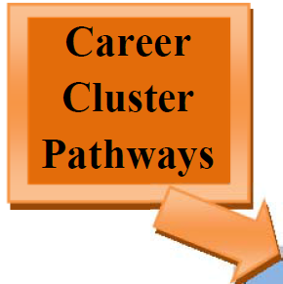
- Agriculture, Food, and Natural Resources
- Architecture and Construction
- Arts, Audio-video Technology, and Communications
- Business Management and Administration
- Education and Training
- Energy
- Finance
- Government and Public Administration
- Health Science
- Hospitality and Tourism
- Human Services
- Information Technology
- Law, Public Safety, Corrections and Security
- Manufacturing
- Marketing
- Science, Technology, Engineering, and Mathematics
- Transportation, Distribution, and Logistics

The information on the next two pages is based on the cluster information and then, 3 sequential pathway course lists that make up a career pathway in one of the 17 Career Clusters. As changes are provided by the Georgia State Department of Education, changes are communicated by school counselors to students and parents. In addition, updates are reflected in both High School 101 and Career Planner Guides.

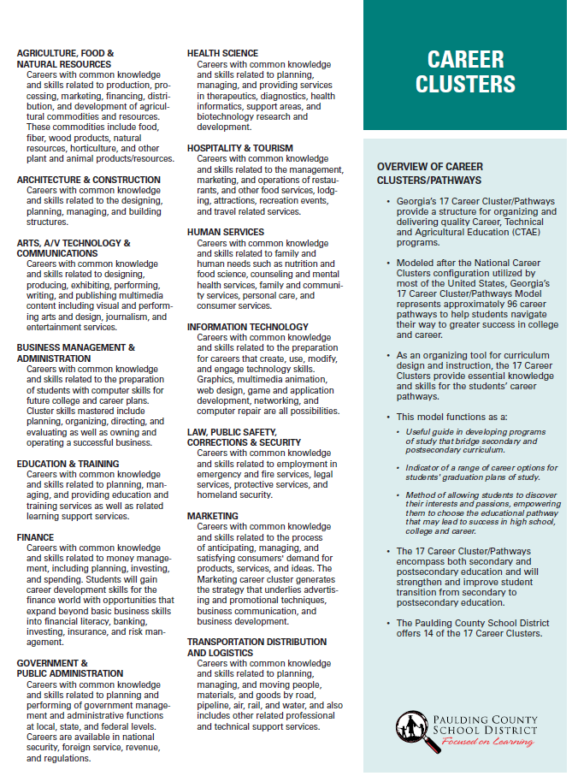

Career Clusters and Pathways for All High Schools
1st course approve Fy13-14, 2nd and 3rd course approve FY14-15
1. Agriculture, Food, and Natural Resources  Food Animal Systems  02.47100 Basic Agriculture Science  02.42100 Animal Science and Biotechnology  01.43200 Agricultural Animal Production and Mgt.  (PCHS)  Plant and Landscape Systems  02.47100 Basic Agriculture Science  01.46100 General Horticulture and Plant Science  01.47000 Nursery & Landscape  (PCHS)  Agricultural Mechanics System  02.47100 Basic Agriculture Science  01.42100 Agricultural Mechanics Technology I  01.42200 Agricultural Mechanics Technology II  (PCHS)  2. Architecture and Construction  Architectural Drawing and Design  48.54100 Introduction to Drafting and Design  48.54500Architectural Drawing and Design I  48.54600Architectural Drawing and Design II  (EPHS-HHS-NPHS)  Carpentry  46.54500 Industry Fundamentals & Occ. Safety  46.54600 Intro. to Construction  46.55000Carpentry I  (NPHS-SPHS)  3. Arts, A/V Technology & Communications  Graphic Design  48.56100 Introduction to Graphics and Design  48.56200 Graphic Design and Production  48.52800 Advanced Graphic Design  (EPHS-HHS-PCHS)  Graphic Communication  48.56100 Introduction to Graphics and Design  48.56200 Graphic Design and Production  48.57000 Advanced Graphic Output  Processes  (HHS-PCHS)  4. Business Management & Administration  Business and Technology  07.44130 Introduction to Business and Technology  07.44100 Business and Technology  07.45100 Business Communication  (All HIGH SCHOOLS)  Entrepreneurship  07.44130 Introduction to Business and Technology  06.41500 Legal Environment of Business  06.41600 Entrepreneurship  (HHS-NPHS)  5. Education and Training  Early Childhood Care & Education  20.52810 Early Childhood Education I  20.42400Early Childhood Education II  20.42600Early Childhood Education Practicum  (PCHS) | Teaching As A Profession (Only 10, 11,12)  13.01100 Examining the Teaching Profession  13.01200 Contemporary Issues in Education  13.01300 Teaching as a Profession Practicum  (EPHS-HHS-NPHS-SPHS)  6. Energy  7. Finance  Business Accounting  07.44130 Introduction to Business & Tech.  07.42600Financial Literacy  07.41100 Principles of Accounting I  (NPHS)  8. Government and Public Administration  JROTC Air Force  28.01100 Aerospace Science: A Journey Into Aviation History Leadership I  28.01200 Aerospace Science: Science of Flight and Leadership II  28.01500 Aerospace Science: Exploration of Space and Leadership III  2801600 Aerospace Science: Management of the Cadet Corps and/or Leadership IV  (EPHS)  JROTC Army  28.03100 JROTC Army Leadership Ed 1  28.03200 JROTC Army Leadership Ed 2  28.03300 JROTC Army Leadership Ed 3  28.03400 JROTC Army Leadership Ed 4  (HHS-NPHS-PCHS-SPHS)  9. Health Science  Therapeutic Services -Allied Health and Medicine  25.52100 Introduction to Healthcare Sci  25.44000 Essentials of Healthcare  25.43700 Allied Health and Medicine  (EPHS)  Biotechnology Research and Development  25.52100 Introduction to Healthcare Sci.  25.57000 Essentials of Biotechnology  25.56900 Application of Biotechnology  (PCHS)  Therapeutic Services – Patient Care  25.52100 Introduction to Healthcare Sci.  25.44000 Essentials of Healthcare  25.43600 Patient Care Fundamentals  (HHS-NPHS-PCHS-SPHS)  Therapeutic Services -Sports Medicine  25.52100 Introduction to Healthcare Sci.  25.44000 Essentials of Healthcare  25.44600 Sports Medicine  (HHS)  10. Hospitality and Tourism  Culinary Arts  20.53100 Introduction to Culinary Arts  20.53210 Culinary Arts I  20.53310 Culinary Arts II  (NPHS-PCHS-SPHS)  Sports & Entertainment Mkt  08.47400 Marketing Principles  08.47800 Intro to Sports & Entertainment  Marketing  08.48500Adv Sports & Entertainment  Marketing  (NPHS) | 11. Human Services  Food and Nutrition  20.41610 Food, Nutrition & Wellness  20.41400 Food for Life  20.41810 Food Science  (EPHS)  Interior Fashion & Textiles  20.44100 Foundations of Interior Design  20.44500Fundamentals of Fashion  20.44700Textile Science  (EPHS)  Personal Care Services – Cosmetology  12.54400 Intro. to Personal Care Services  12.41000 Cosmetology Services II  12.41100 Cosmetology Services III  (ALL HIGH SCHOOLS)  12. Information Technology  Web and Digital Design  11.41500 Introd. to Digital Technology  11.45100 Digital Design  11.45200 Web Design  (EPHS-HHS-NPHS)  13. Law, Public Safety, Corrections and Security  Law Enforcement Services - Criminal Investigations  43.45000 Introd. to Law, Public Safety,  Corrections, and Security  43.45100 Criminal Justice Essentials 43.45300 Criminal Investigations  (HHS-NPHS-SPHS)  14. Manufacturing  15. Marketing  Marketing and Management  08.47400 Marketing Principles  08.44100 Marketing & Entrepreneurship  08.44200 Marketing Management  (EPHS-NPHS-SPHS)  16. Science, Technology, Engineering, and Mathematics  Engineering Drafting and Design Pathway  48.54100 Introduction to Drafting and Design  48.54200 Survey of Engineering Graphics  48.54300 3-D Modeling and Analysis  (HHS)  17. Transportation, Distribution and Logistics  Automobile Maintenance and Light Repair  47.53110 Basic Maintenance and Light  Repair  47.53210 Maintenance and Light Repair 2  47.53310 Maintenance and Light Repair 3  (ALL HIGH SCHOOLS)

Career Pathway Course Information and Descriptions
During the middle school years students complete career portfolios as well as the BRIDGE advisement process. Students are asked to indicate their 1st and 2nd choices of the Career Clusters offered in the Paulding County School District. Students take a Career Pathway within the Career Cluster and become a Career Pathway “completer” when the three pathway courses are completed in sequence. The prior page includes a complete listing of the Career Pathways and the three courses that must be taken to complete a pathway. However, only the first courses offered under each Pathway have course descriptions that are included in this guide.

Important: Class of 2016, 2017 2018, and 2019 students or any student beginning a first pathway course will take the first course in the 17 Career Cluster and Pathway area of interest.

http://www.paulding.k12.ga.us/userfiles/2/my%20files/ctae/pcsd%20career%20planner%20book%202014-2015%20v2.pdf?id=538431

- Agriculture, Food, and Natural Resources
Animal Systems
Plant Systems
Basic Agriculture Science - 02.47100
This course is designed as an introduction or support course for this Program of Study. The course introduces the major areas of scientific agricultural production and research; presents problem solving lessons and introductory skills and knowledge in agricultural science and agri-related technologies. Classroom and laboratory activities are supplemented through supervised agricultural experiences and leadership programs and activities

- Architecture and Construction
Architectural Drawing & Design
Introduction to Drafting and Design - 48.54100
Introduction to Engineering Drawing and Design is a foundation course that serves as an introduction to the drafting and design field and is a prerequisite to all other courses in the Engineering Drawing and Design program. Emphasis is placed on safety, geometric construction, fundamentals of Computer-Aided Drafting, and multi-view drawings. Students learn drafting techniques through the study of geometric construction at which time they are introduced to computer-aided drafting and design. The standards are aligned with the drafting and design standards in the Georgia’s technical colleges, thus helping students qualify for advanced placement should they continue their education at the postsecondary level. Further, the standards are aligned with the national standards of the American Design Drafting Association (ADDA). Students who successfully complete this and other drafting courses should be prepared to take the Drafter Certification Examination from the ADDA. Competencies for the co-curricular student organization, SkillsUSA, are integral components of both the core employability skills standards and the technical skills standards. SkillsUSA activities should be incorporated throughout instructional strategies developed for the course.

Carpentry
Industry Fundamentals and Occupational Safety – 46.54500
This course is the foundational course that prepares students for a pursuit of any career in the field of construction. It prepares the student for the basic knowledge to function safely on or around a construction site and in the industry in general. It provides the student with the option for an Industry Certification in the Construction Core.
This course explains the safety obligations of workers, supervisors, and managers to ensure a safe workplace. Course content discusses the causes and results of accidents and the dangers of rationalizing risks. It includes the basic content of OSHA 10-hour safety standards. It also includes the basic knowledge and skills needed in the following areas: construction math, hand and power tools used in the field, general blueprints, and basics of rigging safety.

- Arts, A/V Technology and Communications
Graphics Design
Graphic Communications
Intro to Graphic Design – 48.56100
This course is the first in a series that prepares the student for employment or entry into a postsecondary education program in the graphic communications career field. Topics to be covered include: Introduction to Graphic Communication Career; Digital File Preparation; Press Operations, Measurement; Safety & First Aid, and Math for Printing.

- Business Management and Administration
Administrative Support
Introduction to Business and Technology – 07.44130
This is a foundations course that introduces practical applications including operating environments, word processing, spreadsheets, database, presentation software, multimedia, graphics, photographic editing, and emerging technologies.

Small Business Development
Introduction to Business and Technology – 07.44130
This is a foundations course that introduces practical applications including operating environments, word processing, spreadsheets, database, presentation software, multimedia, graphics, photographic editing, and emerging technologies.

- Education and Training
Early Childhood Care and Education I
Early Childhood Education I – 20.52810
Introduction to Early Childhood Care prepares the student for employment in early childhood education and services. The course also provides a foundation for advanced study leading to postsecondary education and careers in related fields. The course addresses early childhood care and education and development issues that include guiding the physical, cognitive, creative, social, emotional, and moral development of children. This course of study includes planning and guiding developmentally appropriate practices for working with young children including career paths, principles and theories of child development, the creation of a developmentally appropriate learning environment, collaborative relationships and guidance, lesson planning, and appropriate response to cultural diversity and students with special needs. Mastery of standards through project based learning, technical skills practice, and leadership development activities of the career and technical student organizations will provide students with a competitive edge for either entry into the education global marketplace and/or the post-secondary institution of their choice to continue their education and training.

Teaching as a Profession, Not offered in 9th grade
Examining the Teaching Profession – 13.01100
Examining the Teaching Profession prepares candidates for future positions in the field of education. Teaching Profession candidates study, apply, and practice the use of current technologies, effective teaching and learning strategies, the creation of an effective learning environment, the creation of instructional opportunities for diverse learners and students with special needs, and plan instruction based on knowledge of subject matter, students, community, and curriculum performance standards.
Candidates will be prepared to practice their skills and knowledge at a variety of elementary and secondary education sites. Mastery of standards through project based learning, technical skills practice, and leadership development activities of the career and technical student organizations will provide students with a competitive edge for either entry into the education global marketplace and/or the post-secondary institution of their choice to continue their education and training.

- Energy (No Courses Available)

- Finance
Introduction to Business and Technology – 07.44130
Introduction to Business & Technology is the foundational course for Advanced Accounting, Business Accounting, and Financial Services pathways. The course is designed for high school students as a gateway to the career pathways above, and provides an overview of business and technology skills required for today's business environment. Knowledge of business principles, the impact of financial decisions, and technology proficiencies demanded by business combine to establish the elements of this course. Emphasis is placed on developing proficient fundamental computer skills required for all career pathways. Students will learn essentials for working in a business environment, managing a business, and owning a business. The intention of this course is to prepare students to be successful both personally and professionally in an information-based society. Various forms of technologies will be highlighted to expose students to the emerging technologies in the business world. Professional communication skills and practices, problem-solving, ethical and legal issues, and the impact of effective presentation skills are taught in this course as a foundational knowledge to prepare students to be college and career ready.

- Government and Public Administration
JROTC Air Force
Aerospace Science: A Journey into Aviation History and Leadership I – 28.01100
Aerospace Science: Frontiers of Aviation History is a course that focuses on the frontiers of aviation history. The course is designed to allow students to apply the material. Thus, it is important that the application level activities be emphasized. The course is designed to enable the student to sort through the key aspects of the historical development of flight and the role of the military in history. Students develop and illustrate ideas about attempts to fly in ancient civilizations throughout the world, the first record of scientific study, first flights, and the impact aviation had on the conduct of war. The course enables the students to distinguish the United States’ position at wartime and how wars brought about the development of new weapons, new methods of warfare, new aircraft, more pilots, and the need for pilot training. The course is designed for students to examine the historical development of flight and the role of the military in history. Students explore the U.S. policy of containing the spread of communism and the role of air power during the Korean War, the Cuban Missile Crisis, and the Vietnam War. The students review the peaceful roles and missions in support of national objectives that the military is involved in, and the value of air power during the Persian Gulf War. The performance standards in this course are based on the performance standards.

JROTC Army
JROTC Army Leadership Education I – 28.03100
This course includes classroom instruction and laboratory instruction in the history, customs, traditions and purpose of Army JROTC. It contains the development of basic leadership skills to include leadership principles, values and attributes. Development of core skills students should master, an appreciation for diversity, and active learning strategies are integrated throughout the course. Emphasis is placed on writing skills and oral communications techniques. Financial planning is introduced. Physical fitness, diet, nutrition, healthy lifestyles and awareness of substance abuse and prevention and basic first aid measures are additional content areas. An overview of geography and the globe are incorporated. Also included is a study of the U.S. Constitution, Advisement of Rights, responsibilities of U.S. citizens and the federal justice system. The performance standards in this course are based on the performance standards identified in the curriculum for the US Army JROTC. Successful completion of at least three units of credit in the Army JROTC program will qualify the student for advanced placement in a college ROTC program or Accelerated promotion in the military services.

- Healthcare Science
Therapeutic Services – Allied Health and Medicine
Biotechnology Research and Development
Therapeutic Services – Patient Care
Therapeutic Services Physical Medicine-Sports Medicine
Introduction to Healthcare Science – 25.52100
Introduction to Healthcare Science is a foundations course for the Therapeutic Services Career Pathway. It is appropriate for students wishing to pursue a career in the Healthcare Industry. The course will enable students to receive initial exposure to Healthcare Science skills and attitudes applicable to the healthcare industry. The concepts of health, wellness, and preventative care are evaluated, as well as, ethical and legal responsibilities of today’s healthcare provider. Fundamental healthcares skills development is initiated including medical terminology, microbiology, and basic life support. Students are required to meet both national and intrastate professional guidelines as designated by applicable regulatory agencies such as the Occupational Health and Safety Administration (OSHA) and Center for Disease Control (CDC). Mastery of these standards through project based learning, technical skills practice, and leadership development activities of the career and technical student organization -Health Occupations Students of America (HOSA) will provide students with a competitive edge for either entry into the healthcare global marketplace and/or the post-secondary institution of their choice to continue their education and training. This course is considered broad-based with high impact and is a prerequisite for all Healthcare Science Education courses.

- Hospitality and Tourism
Culinary Arts
Introduction to Culinary Arts – 20.53100
Introduction to Culinary Arts is a course designed to introduce students to fundamental food preparation terms, concepts, and methods in Culinary Arts where laboratory practice will parallel class work. Fundamental techniques, skills, and terminology are covered and mastered with an emphasis on basic kitchen and dining room safety, sanitation, equipment maintenance and operation procedures. Course also provides an overview of the professionalism in the culinary industry and career opportunities leading into a career pathway to Culinary Arts.

Sports and Entertainment Marketing
Marketing Principles – 08.47400
Marketing Principles is the foundational course in the Marketing career cluster. Marketing Principles addresses all the ways in which marketing satisfies consumer and business needs and wants for products and services. Students develop an understanding of the functions of marketing and how these functional areas affect all businesses. They learn basic marketing concepts and the role of marketing in our economy. Students also develop skills in applying economic concepts to marketing, distribution and logistics, marketing information management, finance in marketing, product/service planning, pricing mixes, promotional strategies, and personal selling. In order to increase the number of application experiences, students should participate in work-based learning activities and the student organization, DECA, an association of marketing students. It is highly advantageous for students to participate in a school–based enterprise where available.

- Human Services
Food and Nutrition
Food, Nutrition and Wellness – 20.41610
Food, Nutrition and Wellness is the foundational course in the food and nutrition pathway. The focus of the course is centered on healthy food and lifestyle choices. Students will investigate the interrelationship of food, nutrition and wellness to promote good health. Mastery of standards through project-based learning, technical skills practice, and leadership development activities of Family, Career and Community Leaders of America (FCCLA) will provide students with a competitive edge for either entry into the education global marketplace and/or the post-secondary institution of their choice to continue their education and training.

Interior Fashion and Textiles
Foundations of Interior Design – 20.44100
This course includes classroom instruction and laboratory experience. It is designed to prepare students to understand the work of interior designers and retail buyers. This course includes influences affecting the interior design industry today which includes interior spaces of various types of buildings. Areas of study include: world of interior design; social, psychological and economic influences; trends and issues; elements of design; and interior design principles. This course also deals with the responsibilities of retail buyers, who work closely with designers and sales representatives regarding both fashion and trends.

Personal Care Services -- Cosmetology
Introduction to Personal Care Services – 12.54400
This course is designed to provide the student with an opportunity to become familiar with the cosmetology profession, Georgia State Board of Cosmetology requirements, laws, rules and regulations, and introduces the fundamental theory and practices of the cosmetology profession. Emphasis is placed on professional practices and safety. Competencies for the co-curricular student organization SkillsUSA-VICA are integral components of both the core employability skills standards and the technical skills standards, and SkillsUSA-VICA activities should be incorporated throughout instructional strategies developed for the course.

- Information Technology
Programming
Web and Digital Communications
Introduction to Digital Technology – 11.41500
The goal of this course is to provide all students with an introduction to the principles of computer science and its place in the modern world. This course should also help students to use computers effectively in their lives, thus providing a foundation for successfully integrating their own interests and careers with the resources of a technological society.
In this course, high school students can acquire a fundamental understanding of the operation of computers and computer networks and create useful programs implementing simple algorithms. By developing Web pages that include images, sound, and text, they can acquire a working understanding of the Internet, common formats for data transmission, and some insights into the design of the human-computer interface. Exposure to career possibilities and discussion of ethical issues relating to computers should also be important threads in this course.

- Law, Public Safety, Corrections, and Security
Law Enforcement Services
Introduction to Law, Public Safety, Corrections, and Security – 43.45000
This course will examine the role and structure of government and the rights and responsibilities of citizens in a democratic society. Students will examine the components of the criminal justice system including law enforcement, corrections and the courts. Students will explore differences in the adult and juvenile court systems and between civil and criminal law. The student will also explore and discuss the contributions that private security, protective services, fire/rescue and emergency management make to public safety.

- Manufacturing
(No Courses Available)

15. Marketing
Marketing and Management
Marketing Principles –08.47400
Marketing Principles is the foundational course in the Marketing career cluster. Marketing Principles addresses all the ways in which marketing satisfies consumer and business needs and wants for products and services. Students develop an understanding of the functions of marketing and how these functional areas affect all businesses. They learn basic marketing concepts and the role of marketing in our economy. Students also develop skills in applying economic concepts to marketing, distribution and logistics, marketing information management, finance in marketing, product/service planning, pricing mixes, promotional strategies, and personal selling. In order to increase the number of application experiences, students should participate in work-based learning activities and the student organization, DECA, an association of marketing students. It is highly advantageous for students to participate in a school–based enterprise where available.

16. Science, Technology, Engineering and Mathematics
Engineering Drafting and Design
Introduction to Drafting and Design – 48.54100
Introduction to Drafting and Design is the foundational course for the Architectural Drafting and Design pathway. Emphasis is placed on safety, geometric construction, fundamentals of computer-aided drafting, and multi-view drawings. Students learn drafting techniques through the study of geometric construction at which time they are introduced to computer-aided drafting and design. The standards are aligned with the national standards of the American Design Drafting Association (ADDA).

- Transportation, Distribution and Logistics
Automobile Maintenance and Light Repair
Basic Maintenance and Light Repair – 47.53100
Foundations of Transportation & Logistics is the beginning course for the Transportation Logistical Pathways. It is also appropriate for students enrolled in any career pathway who plan to own and operate their own businesses. The course will help students build a strong knowledge base and develop skills related to logistics in the transportation sector. Mastery of these standards through project-based learning and leadership development activities of the Career and Technical Student Organizations will help prepare students with a competitive edge for the transportation logistics marketplace.

∼∼∼∼STUDY SKILLS∼∼∼∼
(Selected Students/Teacher Approval)
Study Skills - 35.86100
Students will develop and apply skills in successful study methods, test taking, time management and organization, communication, learning styles and career exploration.

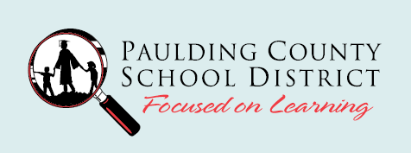

Mission Possible: Graduation and Beyond
BRIDGE Advisement for Class of 2019
High School Elective Course Offerings for 2015-2016

Please refer to HS 101 and or the Career Planner for course information. Use this information to record World Geography, 2 Pathway course choices and 4 Electives in priority order in Section 2 for grade 9 of the BRIDGE Graduation Plan.
Department Name | Course Name | CIP Code | EPHS | HHS | NPHS | PCHS | SPHS
Social Studies | World Geography or Honors | 45.07110 | X | X | X | X | X
Social Studies | AP Human Geography | 45.07700 | X | X | X | X | X
Social Studies | Current issues | 45.01200 |  |  | X
World Language | Spanish I (May have limited enrollment at some high schools.) | 60.07100 | X | X | X | X | X
World Language | Spanish II | 60.07200 | X | X | X | X | X
World Language | French I | 60.07200 | X | X | X | X | X
Fine Arts | Visual Arts/Comprehensive I | 60.01100 | X | X | X | X | X
Fine Arts | Theatre Arts/Fundamentals I | 52.02100 | X | X | X | X | X
Fine Arts | Theatre Arts/Tech Theatre I | 52.04100 |  | X
Fine Arts | Beginning Band I | 53.03610 | X | X | X | X | X
Fine Arts | Beginning Chorus I | 54.02110 | X | X | X | X | X
Fine Arts | Beginning Choral Ensemble | 53.07110 |  |  | X | X | X
Fine Arts | Intermediate Chorus I | 54.02210 |  | X
CTAE* | Basic Ag. Science | 02.47100 |  |  |  | X
CTAE* | Introduction to Drafting & Design | 48.54100 | X | X |  | X | X
CTAE* | Industry Fundamentals & Occ. Safety | 46.54500 |  |  | X |  | X
CTAE* | Intro. To Graphics & Design | 48.56100 | X | X |  | X
CTAE* | Introduction to Business & Tech. | 07.44130 | X | X | X | X | X
CTAE* | Early Childhood Education I | 20.52810 |  |  |  | X
CTAE* | Aerospace Science: Aviation History & Leadership (JROTC-Air Force) | 28.01100 | X
CTAE* | Army Leadership I (JROTC-Army) | 28.03100 |  | X | X | X | X
CTAE* | Intro. to Healthcare Science | 25.52100 | X | X | X | X | X
CTAE* | Introduction to Culinary Arts | 20.43100 |  |  | X | X | X
CTAE* | Marketing Principles | 08.47400 | X |  | X |  | X
CTAE* | Food, Nutrition & Wellness | 20.41610 | X
CTAE* | Foundations of Interior Design | 20.44100 | X
CTAE* | Introduction to Personal Care Services | 12.54500 | X | X | X | X | X
CTAE* | Introduction to Digital Technology | 11.41500 | X | X | X
CTAE* | Intro. To Law, Public Safety, Corrections, and Security | 43.43000 |  | X | X |  | X
CTAE* | Basic Maintenance & Light Repair | 47.53100 | X | X | X | X | X
Physical  Education | Exercise and Weight Control | 36.05500 | X
Other | Study Skills I (By approval only) | 35.06100 | X | X | X | X | X
Personal Fitness and Health are required electives and therefore, all 9th grade students take these two ½ credit courses. Please note within the CTAE information provided that three consecutive years of JROTC with three credits earned will meet the Health and Personal Fitness graduation requirement.
Note: Elective courses change on a yearly basis and course offerings are based on teacher allotments and qualifications plus student interest. Therefore, it is very important to record 4 electives in the Electives section.

Mission Possible: Graduation and Beyond
BRIDGE Advisement for Class of 2019
High School Academic Core and Elective Course Offerings for 2015-2016

This course information is used for grades 9, 10, 11 and 12 of the BRIDGE Graduation Plan and is used in conjunction with the 9th Grade Electives chart on the previous page. The chart below highlights in green the courses that are taken in grade 9 for Section 2 on the plan. The remaining information provides courses that are used to complete Sections 3, 4, and 5 for grades 10, 11, and 12.
The BRIDGE Advisement Plan document is used to create and update your IGP (Individual Graduation Plan) in your GACollege411 account. Please know that your plan is reviewed annually during high school.

Department | Course Name | EPHS | HHS | NPHS | PCHS | SPHS
I. ENGLISH | 9th Literature & Composition | X | X | X | X | X
All levels of Honors and AP courses require an online application process. | Honors 9th Literature & Composition | X | X | X | X | X
 | World Literature | X | X | X | X | X
 | Honors World Literature | X | X | X | X | X
 | American Literature | X | X | X | X | X
 | Honors American Literature | X | X | X | X | X
 | British (English) Literature | X | X | X | X | X
 | Honors British (English) Literature | X | X | X | X | X
 | Multicultural Literature & Composition | X |  | X
 | Writer’s Workshop |  |  |  | X
 | AP Language/Composition | X | X | X | X | X
 | AP Literature/Composition | X | X | X | X | X
Journalism | Journalism I | X | X | X | X | X
 | Journalism II | X | X | X | X | X
 | Journalism III | X | X | X | X | X
 | Journalism IV | X |  | X | X | X
ESOL  Students must qualify to take these courses. | ESOL I |  | X | X | X | X
ESOL  Students must qualify to take these courses. | ESOL II |  | X | X | X | X
ESOL  Students must qualify to take these courses. | ESOL III |  | X | X | X | X
ESOL  Students must qualify to take these courses. | ESOL IV |  | X | X | X | X
II. MATH | CCGPS Coordinate Algebra | X | X | X | X | X
All levels of Honors and AP courses require an online application process. | Accelerated CCGPS Coordinate Algebra-Honors | X | X | X | X | X
 | CCGPS Geometry | X | X | X | X | X
 | Accelerated CCGPS Analytic Geometry-Honors | X | X | X | X | X
 | CCGPS Advanced Algebra | X | X | X | X | X
 | CCGPS Pre-Calculus | X | X | X | X | X
 | Accelerated CCGPS Pre-Calculus-Honors | X | X | X | X | X
 | CCGPS Algebra Support | X | X | X | X | X
 | CCGPS Analytic Geometry Support | X | X | X | X | X
 | CCGPS Advanced Algebra Support | X | X | X | X | X
 | Advanced Math Decision Making | X | X | X | X | X
 | AP Statistics | X | X | X | X | X
 | AP Calculus AB | X | X | X | X | X
III. SCIENCE | Biology | X | X | X | X | X
All levels of Honors and AP courses require an online application process. | Honors Biology | X | X | X | X | X
 | Chemistry | X | X | X | X | X
 | Honors Chemistry | X | X | X | X | X
Department | Course Name | EPHS | HHS | NPHS | PCHS | SPHS
 | Physics | X | X | X | X | X
 | Chemistry | X | X | X | X | X
 | Honors Chemistry | X | X | X | X | X
 | Physics | X | X | X | X | X
 | Physics Honors | X | X | X | X | X
 | Human Anatomy/Physiology | X | X | X | X | X
 | Anatomy/Physiology (Honors) | X |  |  |  | X
 | Earth Systems | X | X | X | X | X
 | Environmental Science | X | X | X | X | X
 | Environmental Science (Honors) |  |  |  |  | X
 | Forensic Science | X | X | X | X | X
 | Zoology | X | X |  | X | X
 | AP Biology | X | X | X | X | X
 | AP Chemistry | X | X | X | X | X
 | AP Physics | X | X | X | X
IV. SOCIAL STUDIES | World Geography | X | X | X | X | X
All levels of Honors and AP courses require an online application process. | Honors World Geography | X | X | X | X | X
 | AP Human Geography | X | X | X | X | X
 | World History | X | X | X | X | X
 | Honors World History | X | X | X | X | X
 | US History | X | X | X | X | X
 | Honors US History | X | X | X | X | X
 | Economics | X | X | X | X | X
 | Honors Economics | X | X | X |  | X
 | Government | X | X | X | X | X
 | Honors Government | X | X | X | X | X
 | Comparative Religions |  |  |  | X
 | Current Issues |  |  | X
 | Psychology-Sociology | X | X | X | X | X
 | AP Government |  | X | X | X | X
 | AP Macro Economics |  | X | X | X | X
 | AP Psychology | X | X | X |  | X
 | AP US History | X | X | X | X | X
 | AP World History | X | X | X | X | X
V. HEALTH & PHYSICAL EDUCATION | Health (.5) and Personal Fitness (.5) | X | X | X | X | X
 | Advanced Body Sculpting | X | X |  | X
 | Advanced Team Sports |  |  | X
 | Advanced Physical Conditioning |  |  | X
 | Advanced Weight Training | X | X | X | X
 | Body Sculpting | X | X | X | X
 | General Physical Education I | X |  |  | X
 | General Physical Education II | X |  |  | X
 | General Physical Education III | X
 | Introduction to Recreational Games |  | X |  |  | X
 | Introductory Lifetime Sports |  | X |  | X
 | Introductory Team Sports |  |  | X
 | Intermediate Lifetime Sports |  | X |  | X
 | Intermediate Team Sports |  |  | X
 | Physical Conditioning |  |  | X
 | Sports Medicine I |  |  | X | X | X
 | Weight Training | X |  | X | X | X
Department | Course Name | EPHS | HHS | NPHS | PCHS | SPHS
VI. CAREER TECHNICAL AND AGRICULTURAL ED. | Use High School 101 pages or Career Planner & GACollege411 individual student Career Cluster Inventory information.
 | Work Based Learning | X | X | X | X | X
WORLD LANGUAGE | French I | X | X | X | X | X
All levels of Honors and AP courses require an online application process. | French II | X | X | X | X | X
 | French III | X | X |  | X | X
 | Honors French III |  | X | X | X
 | French IV |  | X |  | X | X
 | Honors French IV |  | X |  | X
 | Spanish I | X | X | X | X | X
 | Spanish II | X | X | X | X | X
 | Honors Spanish II |  |  | X
 | Spanish III | X | X |  | X | X
 | Honors Spanish III |  |  | X
 | Honors Spanish IV | X | X | X | X
 | Spanish IV Without Honors |  |  |  |  | X
 | AP Spanish | X | X | X | X | X
FINE ARTS | ART |  |  |  | X
 | Visual Arts/Comprehensive I | X | X | X | X | X
 | Visual Arts/Drawing I | X
 | Visual Arts/Drawing & Painting I | X | X | X | X | X
 | Visual Arts/Drawing & Painting II |  |  |  | X | X
 | Visual Arts/Ceramics/Pottery I | X | X | X | X | X
 | Visual Arts/Ceramics/Pottery II, III |  | X | X | X
 | Visual Arts/Photography | X
 | DRAMATIC ARTS
 | Theatre Arts/Fundamentals I | X | X | X | X | X
 | Theatre Arts/Fundamentals II |  | X | X |  | X
 | Theatre Arts/Musical Theatre I |  |  |  |  | X
 | Theatre Arts/Musical Theatre II |  |  |  |  | X
 | Theatre Arts/Musical Theatre III |  |  |  |  | X
 | Theatre Arts/Technical Theatre I | X | X |  |  | X
 | Theatre Arts/Technical Theatre II |  | X |  |  | X
 | Theatre Arts/Technical Theatre III |  |  |  |  | X
 | Theatre Arts/Technical Theatre IV |  |  |  |  | X
 | Theatre Arts/Advanced Drama I | X
 | Theatre Arts/Advanced Drama II | X |  |  |  | X
 | Theatre Arts/Advanced Drama III | X
 | Theatre Arts/Acting I | X |  |  | X
 | Theatre Arts/Acting II | X |  |  | X
 | Theatre Arts/Acting III | X |  |  | X
 | MUSIC-GENERAL
 | Music Appreciation I | X |  | X |  | X
 | Music Appreciation II |  |  |  |  | X
 | Music Appreciation III |  |  |  |  | X
 | MUSIC-BAND
 | Beginning Band I | X |  | X |  | X
 | Beginning Band II | X |  | X |  | X
 | Beginning Band III |  |  | X |  | X
 | Beginning Band IV |  |  | X |  | X
 | Intermediate Band I | X |  | X | X | X
 | Intermediate Band II | X |  | X | X | X
 | Intermediate Band III & IV | X |  | X | X | X
Department | Course Name | EPHS | HHS | NPHS | PCHS | SPHS
 | Advanced Band I | X | X | X | X | X
 | Advanced Band II | X | X | X | X | X
 | Advanced Band III | X | X | X | X | X
 | Advanced Band IV | X | X | X | X | X
 | Mastery Band I |  | X |  |  | X
 | Mastery Band II |  | X |  |  | X
 | Mastery Band III |  | X |  |  | X
 | Mastery Band IV |  | X |  |  | X
 | Beginning Jazz I |  |  |  | X
 | Beginning Instrumental Ensemble I |  | X |  | X
 | Beginning Instrumental Ensemble II |  | X |  | X
 | Beginning Instrumental Ensemble III |  | X |  | X
 | Beginning Instrumental Ensemble IV |  | X |  | X
 | Intermediate Instrumental Ensemble I |  | X | X
 | Intermediate Instrumental Ensemble II |  | X | X
 | Intermediate Instrumental Ensemble III |  | X | X
 | Intermediate Instrumental Ensemble IV |  | X | X
 | Advanced Instrumental Ensemble I | X | X | X |  | X
 | Advanced Instrumental Ensemble II | X | X | X |  | X
 | Advanced Instrumental Ensemble III | X | X | X |  | X
 | Advanced Instrumental Ensemble IV | X | X | X |  | X
 | Beginning Guitar Techniques I |  |  |  | X
 | Intermediate Guitar Techniques I |  |  |  | X
 | MUSIC-CHORUS
 | Beginning Chorus I | X |  |  | X
 | Intermediate Chorus I |  | X | X | X
 | Intermediate Chorus II |  | X | X | X
 | Intermediate Chorus III |  | X | X | X
 | Intermediate Chorus IV |  | X | X | X
 | Advanced Chorus I | X | X | X | X | X
 | Advanced Chorus II | X | X | X | X | X
 | Advanced Chorus III | X | X | X | X | X
 | Advanced Chorus IV | X | X | X | X | X
 | Mastery Mixed Chorus I |  | X |  | X
 | Mastery Mixed Chorus II |  | X |  | X
 | Mastery Mixed Chorus III |  | X |  | X
 | Mastery Mixed Chorus IV |  | X |  | X
 | Advanced Women’s Chorus I | X | X |  | X | X
 | Advanced Women’s Chorus II | X |  |  | X
 | Advanced Women’s Chorus III | X |  |  | X
 | Advanced Women’s Chorus IV | X
 | Advanced Men’s Chorus I |  |  |  | X
 | Advanced Men’s Chorus II |  |  |  | X
ELECTIVES (Other) | SAT Preparation |  |  |  |  | X
Students must qualify to take Study Skills courses. | Study Skills I & II | X | X | X | X | X
Students must qualify to take Study Skills courses. | Study Skills III & IV | X | X | X |  | X

Note: Elective including academic elective courses change on a yearly basis and course offerings are based on teacher allotments and qualifications plus student interest. Therefore, it is very important to record 4 electives in the Electives section of the BRIDGE Graduation Plan document and to change the priority each year as a student’s career interest’s change.

ONLINE COURSE OPPORTUNTIES FOR DISTRICT STUDENTS

As district students plan for high school courses during the 8th grade year, students may consider completing one or more online/virtual courses. Below is the Senate Bill 289 information. For the summer of 2015, parents and students will have a registration process during the months of April, May, June and early July for the 2015-2016 school year. The link to the GADOE Clearinghouse is provided below. District students have the opportunity to complete a course via the district-approved online resources that are available in the school district. School counselors have online information available for students and parents. Any student who requests an online course must have an advisement opportunity provided by his/her school counselor regarding the online request in July or early August.
Parents and students who do not request a course via the SB289 link on the district website by the summer closing date will not be approved to take a SB 289 Online course.

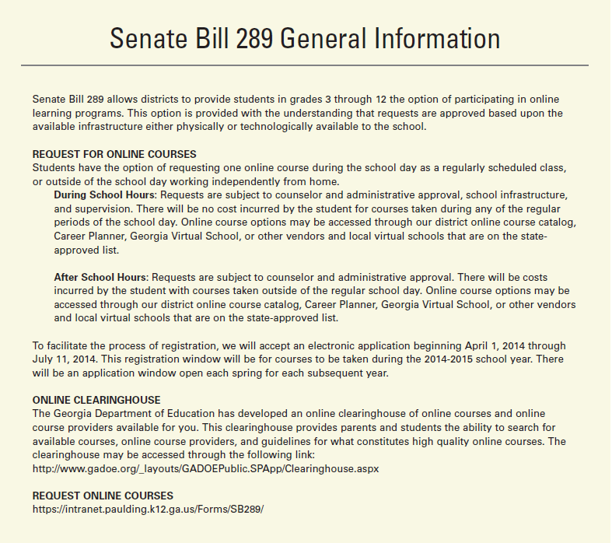

TEST-OUT COURSE OPPORTUNTIES FOR DISTRICT STUDENTS

As district students and parents consider the test-out option for up to three credits during high school, the information from the Georgia Department of Education below must be reviewed. This opportunity is only available for End-of-Course (EOC) assessment courses. An 8th, 9th, 10th, 11th or 12th grade student who meets the qualifications may request to test during a designated EOC testing opportunity. March 2015 will be the test-out opportunity offered to district students for one or more of the EOC course tests. Only 3 credits can be earned at this time via this process. It is anticipated that the parent/student registration to request a test-out opportunity in one or more courses will occur during the month of January. School counselors will provide specific information when it is made available. Important: At the writing of HS101 these specifics are not yet available as the Georgia Department of Education has not laid out a final plan for the new End-of-Courses test-out assessments.

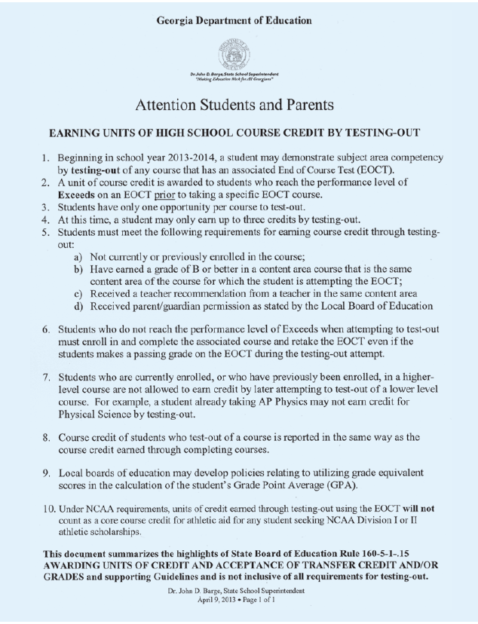

CAREER DEVELOPMENT

Once you graduate, in four years, you will begin your “postsecondary” education life. An important part of your high school years as well as your career will be to gain the knowledge and skills so that you will earn money to support yourself, and later on, perhaps support a family. In this section you will begin to think about options after high school and what career might make the best fit with your interests. Once you identify your career choice, you will learn as you move through high school what steps you will take to reach your career goals. Always keep your career plan in mind as you sign up for courses and have the opportunity to gain new skills.

These are the standards for this section:
Standard A: Students will acquire the skills to investigate the world of work in relation to knowledge of self and to make informed career decisions.
Standard B: Students will employ strategies to achieve future career goals with success and satisfaction.
Standard C: Students will understand the relationship between personal qualities, education, training, and the world of work.
(Source: The American School Counselor Association National Model)

School counselors will assist you with the fountain of information that is available for students and for parents to assist students in making plans after high school. Counselors assist students in utilizing the GACollege411 (web-based), completing items on the BRIDGE Advisement checklist, and utilizing a variety of other tools to focus on career interests. Counselors help students develop a BRIDGE Advisement educational and career plan while assisting students in their assessment of interests, goals and plans after high school. A student might take advantage of one or more of these options:
Attend a four-year college or university
Attend a two-year college or two-year technical college
Work full-time or part-time
Join the military
Participate in an internship or apprenticeship

Have a career plan in mind the entire time you are in high school. Whichever route you take after high school, be certain what you are doing in high school will support your career plan!

PLANS of STUDY

As they work with students in 8th grade and throughout high school, counselors encourage students to be pathway completers. A student is a pathway completer when he/she concentrates in the CTAE, Advanced Academic (English, Mathematics, Science, Social Studies, World Language) and/or Fine Arts Pathway courses. Each student follows the GaDOE Plan of Study along with the BRIDGE Advisement Plan/Individual Graduation Plan in GACollege411.

As already stated in this guide, selection of a pathway area is based on self-awareness and investigation of careers. In addition, students learn about high school courses related to the pathway as well as post-secondary skills and course work needed to be prepared for a career in the focused area. Most high-demand, high-skilled, high-wage occupations in all pathway concentration areas require education beyond high school.

The Georgia Department of Education link for all Plans of Study is:
http://www.gadoe.org/Curriculum-Instruction-and-Assessment/CTAE/Pages/Georgia-Career-Pathways-New-Rule.aspx


THINKING ABOUT COLLEGE?

Studies show that nearly 90% of beginning high school students want to go to college. It is not too early to begin preparing for that option. Below are some criteria that most colleges and universities use in their admission standards. Grades, practicing knowledge and skills via homework opportunities, and taking challenging math courses all matter as you prepare for college.

Criteria for College Admissions

Academic Rigor. Colleges look at what courses are taken in relation to what is offered at the high school. Admissions office staff evaluate all four years of high school, especially courses taken during the senior year. The program should be strong in Math, Science, English, Social Studies and World Language. College admissions counselors look for honors and advanced placement courses where appropriate and, of course, prefer high grades in these classes. Students should plan to take what are called "gateway" courses which enable a student more opportunities for post-secondary studies. Some of these gateway courses are in the areas of Mathematics, Chemistry, and Physics.

CORE GPA. Many colleges review and re-calculate grade point averages on CORE courses only, i.e., English, Math, Science, Social Studies and World Language. It is critical that 9th grade students keep this in mind during the 9th grade year and earn high grades! Additionally, it is always wise to contact the admissions office at a college or university and ask how the GPA is calculated for entering freshmen students.

Extracurricular/Community Service. Colleges also consider a student's involvement in extracurricular activities and community service to determine a student's leadership qualities. Any opportunity a student has to be a member of school clubs and organizations and/or to do volunteer work in the community is highly recommended.

Grades. A student's grades in core courses (English, Math, Science, Social Studies, and World Language) are reliable predictors of college academic success. Grades in these courses plus SAT/ACT scores are the two primary predictors used. A high school transcript is generally evaluated twice by most colleges; once to determine that the candidate meets the institution's minimum requirements and a second time to determine the difficulty of the candidate's program of high school studies.

Letters of Recommendation. These are the least important in determining college admission, but are considered. The effort a student puts forth in a teacher's class is largely the basis for making a strong recommendation. Students are encouraged to show every teacher their best effort.

Standardized Test Scores. SAT/ACT scores are an excellent predictor of academic success. In Georgia, a student's SAT/ACT scores are used in a formula called the "Freshman Index" to determine regular college admission. Typically, students take the SAT/ACT during their junior year for the first time. High school counselors have information regarding tests and dates. Information is available on The College Board and ACT websites.

http://sat.collegeboard.com/home

http://www.act.org/aap/

COLLEGE ADMISSIONS

At all of Georgia’s public colleges and universities, a minimum of 17 core units are required for regular admission. In addition, depending upon the particular university or college, more academic units may be required. The minimum requirements by university or college status are outlined below. Parents and students are encouraged to obtain current information/requirements from the colleges they are considering and communicate with them concerning admissions practices and policies. An excellent resource for in state schools is GACollege411.org.

FRESHMAN INDEX (SOURCE: www.gacollege411.org )

Freshman Index Requirements and Freshman Index
The Freshman Index is calculated by combining the high school grade point average (GPA) with the highest earned SAT or ACT test scores. The high school GPA is calculated from the grades earned in the 17 Required High School Curriculum (RHSC) courses for those students graduating 2012 or later.
The following formulas are used to calculate a student's freshman index:
Formula for SAT Test Takers | Formula for ACT Test Takers
Freshman Index =  (500 x High School GPA)  + SAT Critical Reading + SAT Math | Freshman Index =  (500 x High School GPA)  + (ACT Composite score x 42) + 88

Required High School Curriculum (RHSC) for Students Graduating High School 2012 or Later
Students graduating high school in 2012 or later should complete the following curriculum:
Carnegie Unit Requirements* | In Specific Subject Areas
4 units English | Literature (American, English, world) integrated with grammar, usage and advanced composition skills
4 units mathematics | Mathematics I, II, III, and a fourth year of advanced math or equivalent courses
4 units of science | The four science units should include two courses with a laboratory component. Students graduating from a Georgia public high school should have at least one unit in biology, one unit of physical science or physics, one unit of chemistry, earth science or environmental science and a fourth science.
3 units social science | Must include one unit focusing on U.S. studies and one unit focusing on world studies
2 units of the same World Language or Am. Sign Lang. | Emphasizing speaking, listening, reading and writing skills
*Note: A Carnegie unit is a full academic year of credit
Type of Institution | Minimum Freshman Index (FI)
Research Institutions | 2500
Regional Universities | 2040
State Universities | 1940
State Colleges | 1830¹
Two-Year Colleges | No FI Requirement
¹ Not required by all state colleges. Check with the admission office for additional information.

CALCULATING GRADE POINT AVERAGE

To determine a student’s GPA at any time, add all final numerical grades from all courses, then divide by the total number of courses attempted. All courses must be broken down into ½ credits. Seek input from your high school counselor regarding the calculation of your grade point average. Paulding County uses a numeric GPA scale for the purposes of class rank. The district transcript has both numeric grade point averages weighted and unweighted and 4.0 scale grade point averages weighted and unweighted. It is important to note that the HOPE scholarship eligibility is based on a 4.0 scale GPA, A=4.0, B=3.0, C=2.0, and F=0.0. Only academic core and elective courses are used in this calculation. Only Advanced Placement courses with a passing grade are weighted on the HOPE transcript.


SAT, ACT TESTS AND TEST PREPARATION

SAT

Students who graduated from high school in 2006 were the first class to take the
new SAT for college admissions. The new SAT has three sections: Critical Reading (called Verbal, prior to 2006); Math; and Writing (new section). The Critical Reading section adds shorter reading passages to existing long reading passages, but eliminates analogies. The Math content was expanded to include topics from third-year college prep math, and eliminated quantitative comparisons. The Writing components include multiple-choice questions on grammar and usage plus a short student-written essay that requires them to take a position on an issue and use examples to support their position. Colleges and universities require that the writing test be taken, but still use the Critical Reading and Math scores to evaluate incoming students. SAT (Scholastic Aptitude Test) scores are a good predictor of a student’s academic success at least for the first year of college. Colleges look at SAT scores, grade point average in core areas, and the actual high school courses taken in their admissions selections.

IMPORTANT IMPORTANT IMPORTANT IMPORTANT

While the best SAT preparation is through rigorous and challenging course work in which the student puts forth maximum effort, students are strongly encouraged to go to www.GAcollege411.org to take advantage of two comprehensive resources for Georgia High School students to help them prepare for the SAT.
SAT Companion
The GAcollege411 SAT Companion features easy-to-use tutorials, interactive practice sessions, techniques and strategies, and more, to strengthen academic skills in preparation for the SAT. The test-prep courses automatically adapt to the student’s skill level, give immediate feedback to answers, and offer helpful hints, tips, and explanations for the types of questions and subjects found on the exam. The SAT Companion provides overview information about the different sections of the SAT test along with a list of frequently asked questions about the SAT test.
ACT
The ACT (American College Test) is designed to assess high school students’ general educational development and their ability to complete college-level work. The test covers four skill areas: English, Mathematics, Reading, and Science. ACT also has a Writing Test which is 30-minutes long. Postsecondary institutions require that students take this writing test. Colleges and universities make their own decisions about using the results of the ACT Writing Test.


HOPE SCHOLARSHIP REQUIREMENTS

Summary of HOPE Scholarship Information
HELPING OUTSTANDING PUPILS EDUCATIONALLY

It is extremely important that HOPE Scholarship information be checked by the student and parent on GACollege411 as the requirements and details may change from year to year.

HOPE SCHOLARSHIP: HOPE Scholarship (students seeking a degree) basic eligibility requirements for HOPE Scholarship have NOT changed: be a citizen, be a Georgia resident, register with the Selective Service (if applicable), be in compliance with Georgia Drug-Free Postsecondary Education Act of 1990, attend a Georgia eligible school, graduate with a 3.0 GPA in core courses, maintain a 3.0 while in college.

HOPE SCHOLARSHIP ELIGIBILITY
https://www.gacollege411.org/Financial_Aid_Planning/HOPE_Program/Georgia_s_HOPE_Scholarship_Program_Overview.aspx
• 3.0 HOPE GPA
• Core curriculum courses that have been completed in grades 9-12.
• GSFC must receive a letter or numeric grade for each core course in order to calculate HOPE GPA
• Rigor Requirements/• Credit Courses Needed
• Class of 2015 need 2 rigorous courses
• Class of 2016 need 3 rigorous courses
• Class of 2017, 2018, 2019+ need 4 rigorous courses
- The HOPE Scholarship will pay:
  - At an eligible public postsecondary institution, for FY2015 a percentage amount of the standard tuition charges from the previous year. View award amounts at: http://www.gsfc.org/main/publishing/pdf/2012/hope_award_amounts.pdf. Every year these amounts will change based upon lottery revenues, HOPE enrollment numbers, and the previous year’s award rate;
  - At an eligible private postsecondary institution, a percentage amount of the HOPE award for the private colleges (for FY 2015 the maximum amount is $3,600/year for 15 hours);
  - A separate Tuition Equalization Grant (TEG) in the amount of $700 for FY 2013 is also available for students attending eligible private colleges in Georgia;
  - No book or fee allowances;
- The HOPE Scholarship will NOT pay for remedial or development courses;
- If a student falls below a 3.0 GPA while in college, he/she may regain the HOPE Scholarship only one time;
- Beginning with the Class of 2015 (students entering high school 2011-2012), a new rigor requirement has been added. Students graduating in 2019 must pass at least 4 courses from a list of academically rigorous courses to meet requirements to be a HOPE Scholar upon high school graduation (i.e., courses in advanced math, advanced science, advanced foreign language, AP or IB courses in core subjects, and/or College Credit Now/dual enrollment courses taken as a unit of the University System of Georgia in core subjects, remedial or developmental). GSFC will provide a list of classes to further define each category.
HOPE Scholarship Award Limits
A college degree-seeking student becomes ineligible for the HOPE Scholarship once the student has: • Received payment from any combination of HOPE Scholarship, and HOPE Grant funds totaling 127 semester hours (190 quarter hours) of credit; or • Attempted 127 semester hours (190 quarter hours) of college degree credit, regardless of whether HOPE funds were received while attempting the hours; or • Earned a baccalaureate (four-year) college degree, regardless of whether HOPE funds were received while earning the degree.
Apply for the HOPE Scholarship--Spring of Senior Year, complete Free Application for Federal Student Aid

ZELL MILLER SCHOLARSHIP ELIGIBILITY
https://www.gacollege411.org/Financial_Aid_Planning/Scholarships/Zell_Miller_Scholarship/Zell_Miller_Scholarship_Program_Overview.aspx
• Valedictorian or salutatorian must meet basic HOPE Scholarship eligibility requirements or HOPE GPA and test scores
• 3.7 HOPE GPA
• Core curriculum courses
• Rigor Requirements/• Credit Courses Needed
• Class of 2015 need 2 rigorous courses
• Class of 2016 need 3 rigorous courses
• Class of 2017, 2018, 2019+ need 4 rigorous courses
• Test requirements
• 1200 SAT combined score (critical reading and math)
• 26 ACT composite score
- Maintain at least a 3.3 GPA in college to remain eligible for the Zell Miller Scholar program;
- The Zell Miller Scholar payment guidelines are the following…
- For Georgia public universities/colleges or Georgia Technical colleges, Zell Miller Scholars will have their tuition fully paid during the then current year, without regard for specific program of study;
- For Georgia private colleges, Zell Miller Scholars will receive $4,000/yr for 15 hours for FY 2012;
- On-line chart for Zell Miller Scholar award amounts for Georgia public institutions is the second page of the following link: http://www.gsfc.org/main/publishing/pdf/2012/Zell_Miller_Award_Amounts.pdf

HOPE GRANT
https://www.gacollege411.org/Financial_Aid_Planning/HOPE_Program/Georgia_s_HOPE_Grant_Program.aspx
• Eligibility-High school GPA and/or test scores not considered
• Enrolled in a certificate or diploma program
• Award Amount
• Portion of the standard tuition
• Award amount chart available on GAcollege411.org
• Strategic Industries Workforce Development Grant (SIWDG)
• Created to help students enrolled in certain high-demand certificate and diploma programs at Technical College System of Georgia (TCSG) schools pay for their education
• Eligibility requirements for SIWDG are same as for HOPE Grant

CLASS OF 2019 HOPE RIGOR REQUIREMENTS

http://www.gsfc.org/main/publishing/pdf/2012/Rigor_Explanation.pdf
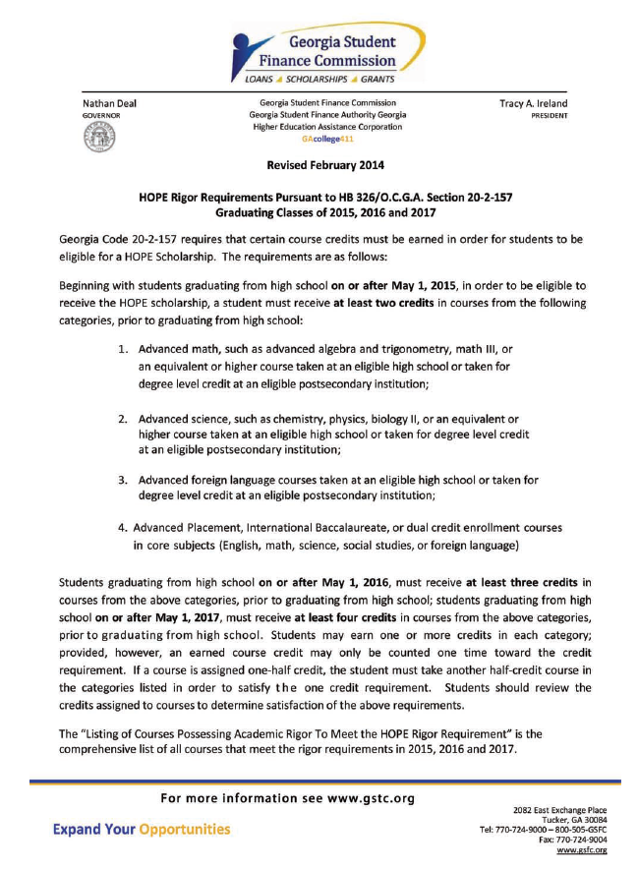

MINIMUM REQUIREMENTS BY INSTITUTIONAL LEVEL

Thanks to a decision made by the Board of Regents of the University System of Georgia, students now enjoy greater flexibility in planning a high school course of study that prepares them for admission to Georgia’s public colleges and universities. The current graduation rule requires 23 credits earned to receive a high school diploma. Colleges and universities in the state of Georgia, also require that entering freshmen have successfully completed a minimum of two World Language credits in the same language for admission. The new graduation rule provides for students to select courses that meet the needs of their individual advisement and career plans, without limiting their options for continuing their education after they graduate from high school.

Research Universities
Georgia State University, University of Georgia, Georgia Tech, Medical College of Georgia
- 17 Core Units are required. 4 additional academic units are recommended.
- Honors and Advanced Placement coursework highly recommended.

Regional Universities
Georgia Southern, Valdosta State
- 17 Core Units are required. 2 additional academic units are recommended.
- Honors and Advanced Placement coursework recommended.

State Universities and Senior Colleges
Kennesaw State, University of West Georgia, Southern Tech, Clayton State College,
North Georgia, Albany State, Armstrong Atlantic State, Fort Valley State, Georgia
College and State University, Savannah State, Dalton College
- 17 College Core Units are required. 2 additional academic units are recommended.
- Honors and Advanced Placement coursework recommended

Two-Year Colleges
Abraham Baldwin Agricultural College, Georgia Highlands College, Middle Georgia College,
DeKalb College, South Georgia College, Gordon College, Gainesville College, Atlanta Metropolitan
- 17 Core Units are required.

Technical Colleges
Chattahoochee Tech, North Metro Tech, Coosa Valley Tech, Carroll Tech, and others
- 15 Core Units

Technical schools want students to enroll in the most rigorous math and science classes possible. Higher level math and science are recommended if the student is seeking an Associate Degree. All students must take the ASSET Test. Certain scores must be obtained before admission into certain programs. Technical degrees lead to 4-year degrees in the Bachelor of Applied Science (BAS) Program. The BAS is established through an articulation agreement between the technical schools in the state of Georgia and three (3) 4-year institutions (Clayton State, Dalton College, and Valdosta State).

BRIDGE ADVISEMENT AND CAREER PLANNING

BRIDGE Advisement is mandated advisement and by law students in grades 6-12 must complete certain advisement tasks each year. Students, along with their parents/guardians make plans and career decisions throughout middle and high school. This law supports the district counseling motto which is MISSION POSSIBLE: Graduation and Beyond. Professional school counselors support all students in the advisement process to meet career goals beyond high school. The following information provides you with the BRIDGE ADVISEMENT CHECKLIST/TASKS for grades 6-12 (Using GAcollege411.org):

Account/User Name: PCSDXXXXX (XXXXX=5 digit student number)
Password: mmddyyyy (birth date only unless does not work, then add first, middle and last name initials)
Very Important: Student must not change user name and password without contacting school counselor.

6th Grade-Account Set-up and the Interest Profiler
School Counselors batch add all students’ accounts in GACollege411. Counselors also add new students as they are enrolled in middle school within the school district.
Students take one of the six interest inventories, the Interest Profiler, and save this interest inventory to their portfolio in their My411 account.
___________________________________________________________

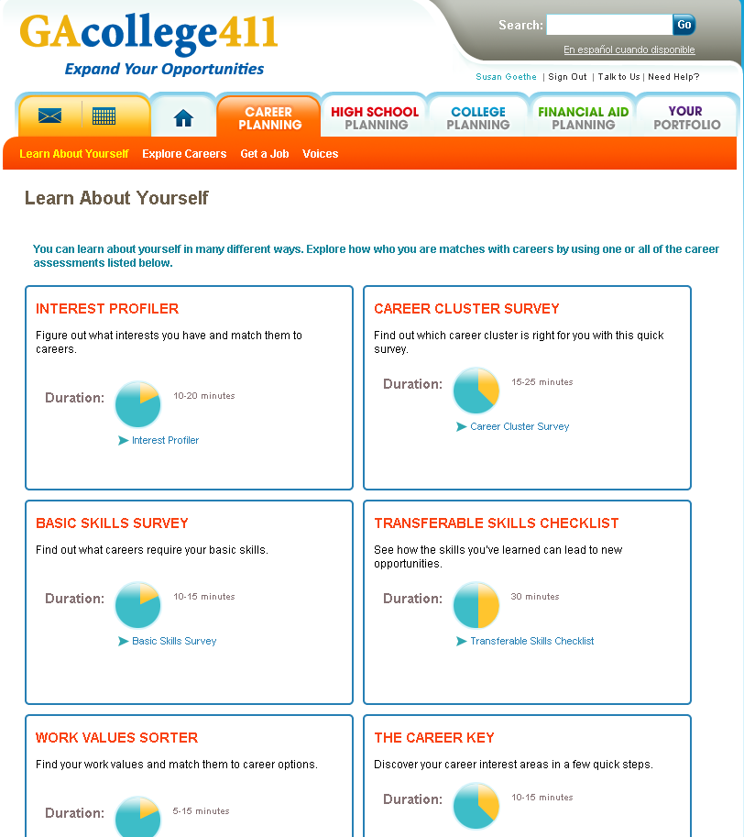

7th Grade
Career Cluster Survey, a career interest inventory, and Exploration of 3 Career Concentrations/Clusters
___________________________________________________________
The Career Cluster Survey is taken during the 7th grade year and saved to the student’s My411 Portfolio. Students also explore at least 3 career concentrations/clusters and save the career clusters/concentration in the My411 portfolio.

8th Grade
Students explore and research 3 careers. The BRIDGE Advisement Graduation Plan is completed and then, GACollege411 is used to update the students’ Individual Graduation Plan/Plan of Study.
Students are provided with College Credit Now /Dual Enrollment information.
___________________________________________________________

Students explore at least three careers/occupations and save the career information to the GaCollege411 portfolio:

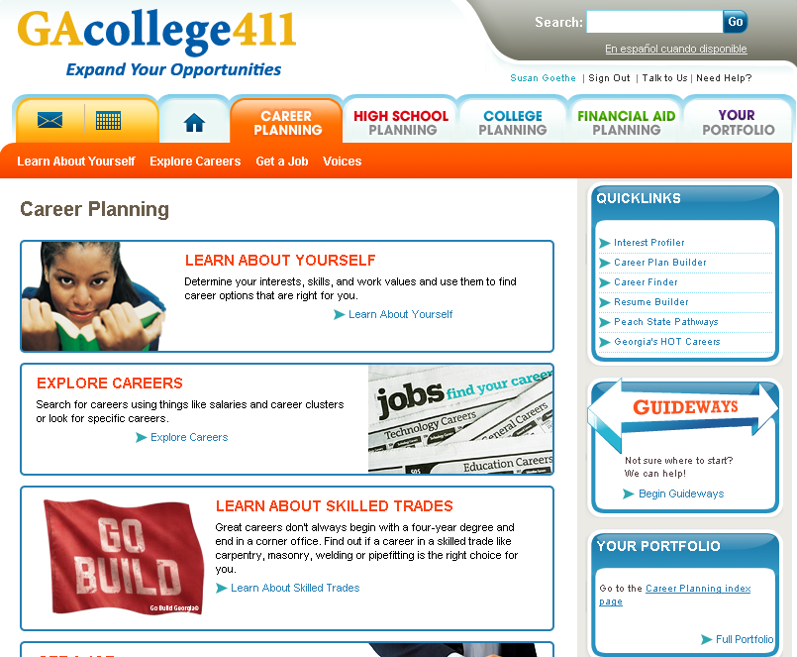
The Individual Graduation Plan

See district BRIDGE Advisement Plan to complete all high school years for grades 9, 10, 11 and 12 on page 1 of the plan. All district 8th grade students are required by law to create and update the Individual Graduation Plan during advisement opportunities in grades 8, 9, 10, 11, and 12. This plan is maintained on each student’s My411 portfolio.

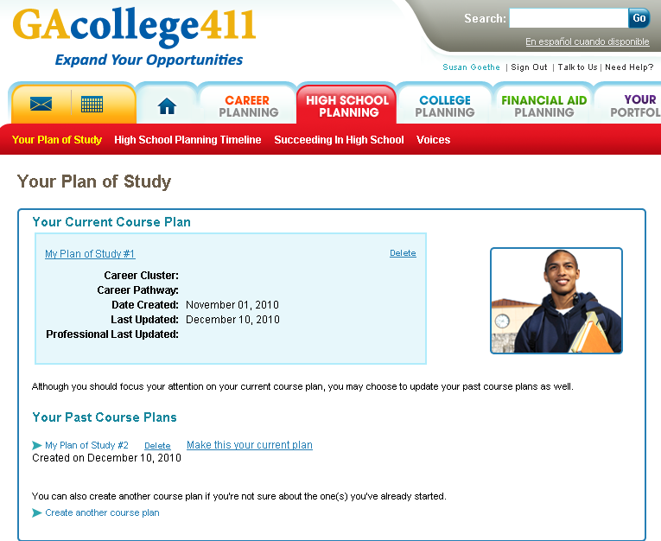

Using the BRIDGE Advisement Plan document (see below), the student can update the GACollege411 “Your Plan of Study” information (please note sections S.2, S.3, S.4 and S.5):

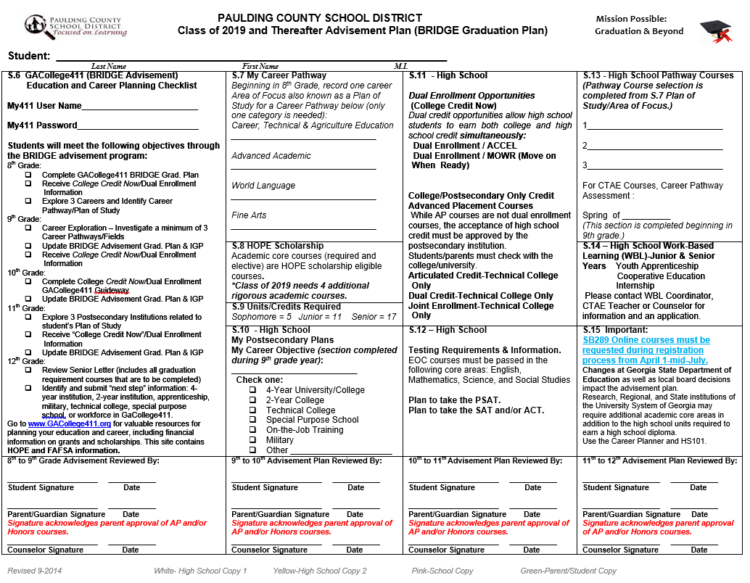

Both students and parents may review an updated GaCollege411 Individual Graduation Plan at any time after the first IGP is updated during 2nd semester of the 8th grade year. This plan is found in the student’s GaCollege411 portfolio. Beginning in the 9th grade year the IGP is updated annually with both completed and enrolled courses.
BRIDGE Advisement “Individual Graduation Plan”
(Document Below Mirrors the GACollege411 Individual Graduation Plan; Students use BRIDGE Advisement Graduation Plan as a guide. Students complete 9th, 10th, 11th, and 12th grade years during 8th grade.)
 | 9th Grade | 10th Grade | 11th Grade | 12th Grade | Total Units
English/
Language Arts
Math
Social Studies
Science
Health
Physical Education
CTAE
World Language
Fine Arts
Electives

4-year Total: _____

9th Grade
Students investigate further the 3 careers selected during 8th grade or may review and research three additional careers/occupations in the career interest area(s).
They also update the BRIDGE Advisement Plan and IGP in GaCollege411 and are provided College Credit Now /Dual Enrollment information.
___________________________________________________________

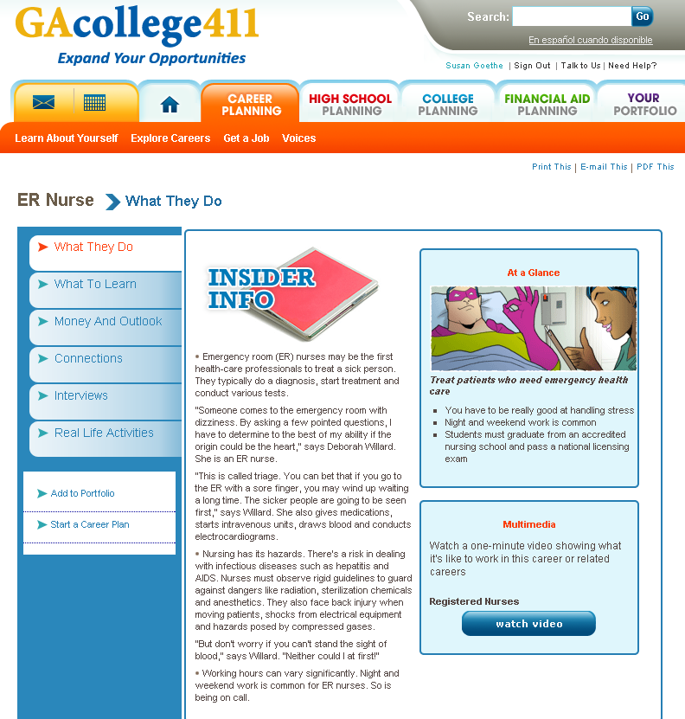

10th Grade
Students update the BRIDGE Advisement Plan and IGP in GACollege411
10th grade students receive College Credit Now /Dual Enrollment and must also complete the College Credit Now tasks that are on GaCollege411. ___________________________________________________________

Becoming aware of College Credit Now (Dual Enrollment) programs by April 1 is required by Georgia law (note information under High School Planning tab):

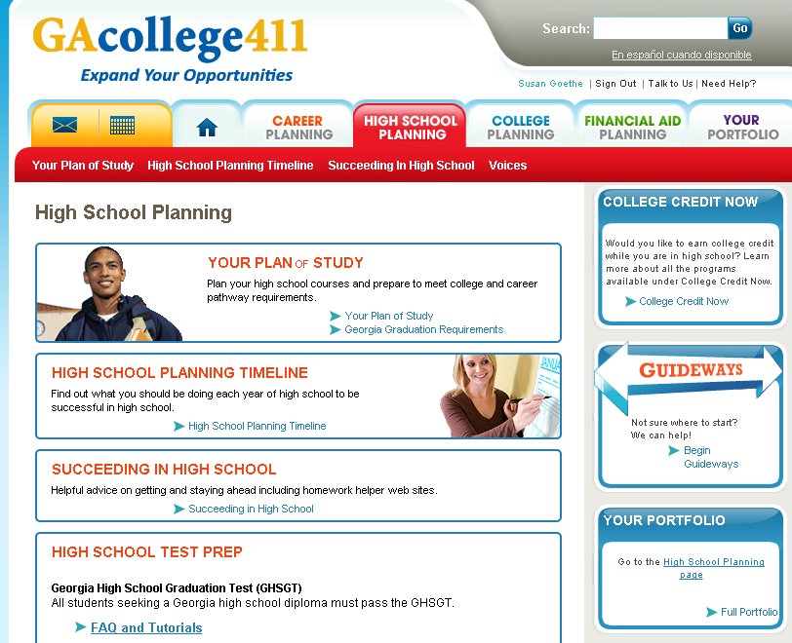

11th Grade
Students explore and save 3 postsecondary institutions that support the BRIDGE Advisement Graduation Plan. Students once again update the BRIDGE Advisement Plan and IGP in GACollege411 and receive information regarding College Credit Now /Dual Enrollment.
___________________________________________________________
For students making the connections between school and work by exploring and saving three possible choices of postsecondary institutions that match the Individual Gradation Plan (BRIDGE Advisement Plan) is important.
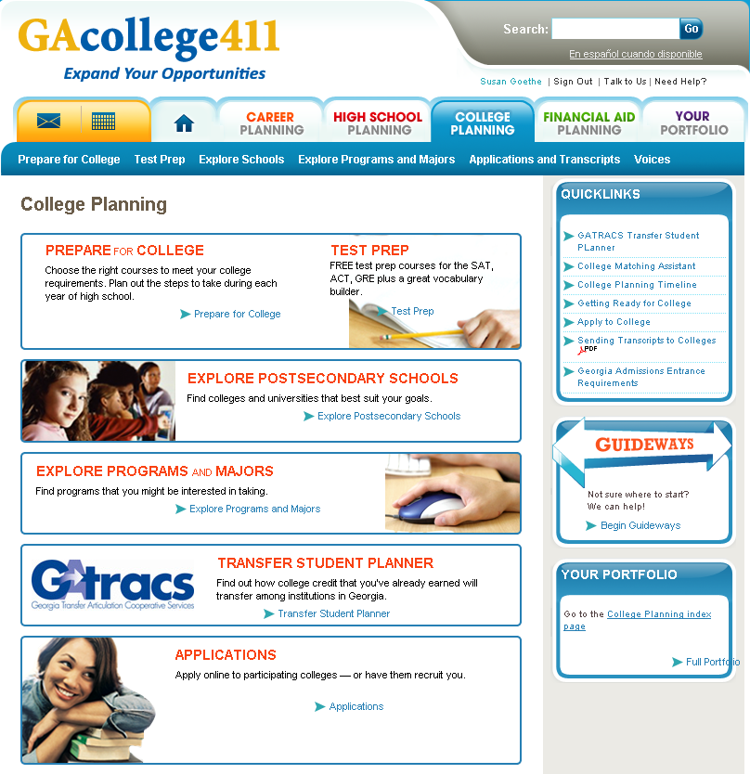

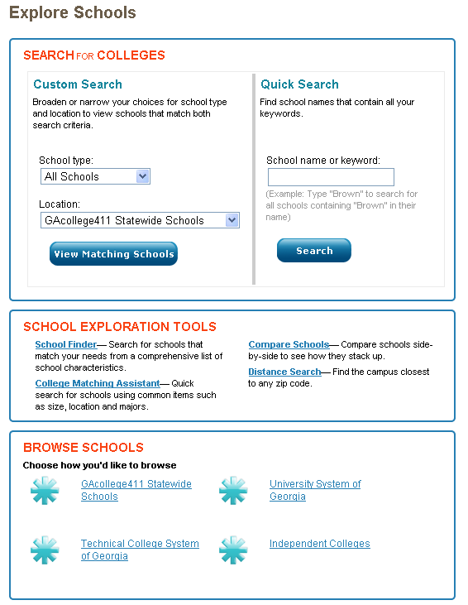

12th Grade
During August or September of the senior year, district 12th grade students and parents understand and review both pages of the Senior Letter. In addition, students use GaCollege411 to identify the “next step” after high school graduation which may be a 2 or 4 year college, technical college, military, specialize school, apprenticeship or work.
___________________________________________________________

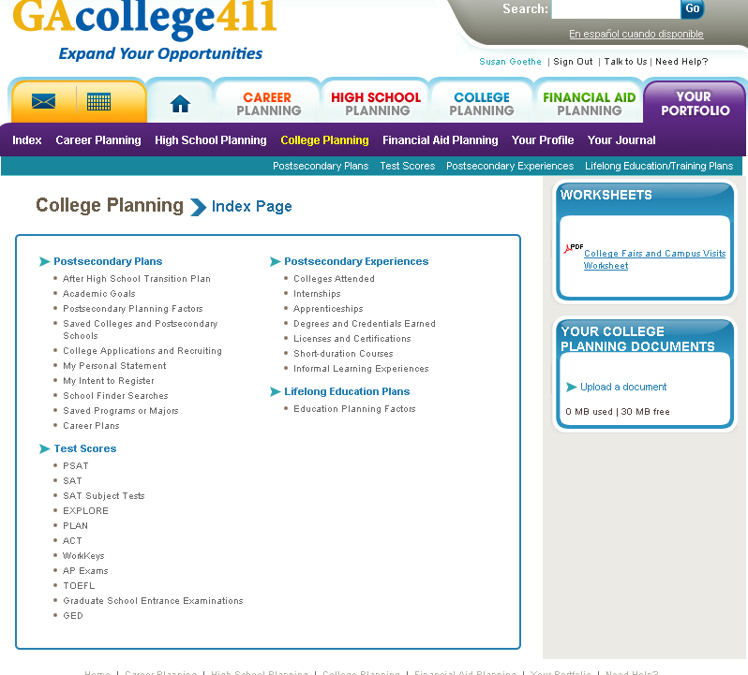

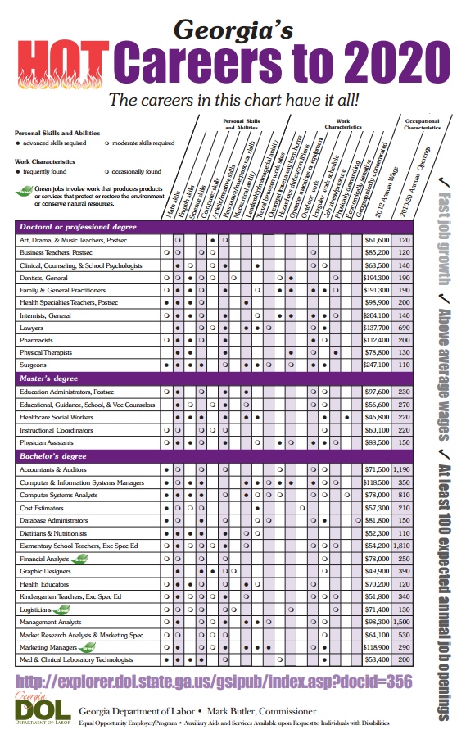

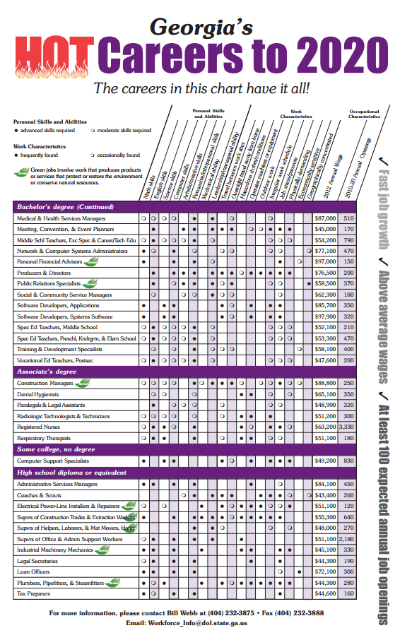

CAREER INTERESTS - IT’S ALL ABOUT YOU
Who are you? What do you like? What do you dislike? The more you know about yourself, the better decisions you will be able to make as you develop your high school and postsecondary flight plan. Career assessments are a good way to learn more about you, and GAcollege411 has several from which to choose. Go to Discover a career path that’s right for you and choose at least the following:

- Interest Profiler – Find out what interests you have and what careers match them
- Work Values Sorter – Identify the things that you believe in and feel are important to you
- Career Cluster Survey – Match your interests and personal qualities to career pathways/clusters
Match your interest profile to a career:
Realistic (R)  Cook  Firefighter  Roofer  Automobile Mechanic  Carpenter  Air traffic controller  Emergency medical technician  Building inspector  Machinist  Heavy truck driver  Paramedic | Investigative (I)  Audiologist  Computer programmer  Physician  Physician’s assistant  Pharmacist  Chemist  Biologist  Architect  Geoscientist  Veterinarian  Surgical technician | Artistic (A)  Architect  Commercial artist  Singer  Reporter  Graphic designer  Actor  Musician  Book editor  Floral designer  Author  Animator
Social (S)  Nursing aide  Counselor  School administrator  Aerobics instructor  Medical sonographer  Teacher  Correctional officer  Coach  Physical Therapist  Nurse  Preacher | Enterprising (E)  Travel agent  Real estate sales agent  Sales manager  911 dispatcher  Child care worker  Farm manager  Financial manager  Lawyer  Construction manager  Cosmetologist  Entrepreneur | Conventional (C)  Accountant  Legal secretary  Insurance underwriter  Bank teller  Medical records technician  Administrative assistant  Cashier  Computer support specialist  Network technician  Library technician  Office clerk

Name 3 careers that are of interest to you:
- ____________________________________________

- ____________________________________________

- ____________________________________________

KNOW YOUR OPTIONS / TWO
Knowing more about you is especially important at this point in your education career. Even before you finish your eighth grade year, you will be given many choices and asked to make several decisions about ninth grade and beyond. Before you can begin making those decisions, though, you need to know your options.

“The secret of success in life is for a man to be ready for his opportunity when it comes.” Benjamin Disraeli

CAREER CLUSTERS/PATHWAYS AND YOUR INTERESTS

The results of your Career Cluster Survey matched you and your interests to two or three of the 16 national Career Clusters and the additional Energy cluster for the state of Georgia. In Georgia, those clusters have been combined to form 17 Career Concentrations. The Paulding County School System offers thirteen of Georgia’s Career Concentrations and multiple career pathways. Note CTAE pages in this guide. Also, use the most recent Paulding County Career Planner and the worksheet beginning on the next page:
- Identify what pathways are offered under each Career Concentration of interest
- Write down the high school(s) offering each pathway
- As you investigate each pathway, note at least three careers that are related to each Career Concentration/Pathway
- Highlight the pathways that are currently offered by the high school that you will attend
- Use the results of your Interest Profiler, Career Cluster Survey, and research of careers plus step 4 above, and name 2-3 pathways that you might want to pursue in high school:

______________________________________

______________________________________

______________________________________

A CLOSER LOOK AT CTAE PATHWAYS

Georgia’s Career Pathways include a specific sequence of academic and career-related courses that, if completed in high school, can lead to industry certification or licensure, an Associates (2-year) degree, and/or a Baccalaureate (4-year) degree and beyond. The goal is that you will be prepared to do at least one of the following things once you have graduated from high school: 1.) get a job, 2.) enter the military, or 3.) start a college program.

Using the Paulding County Career Pathways Chart in this guide or the Career Planner, complete the following information for two pathways of your choice:

Pathway #1 _____________________________________
Pathway Concentration Courses:

_______________________________________

_______________________________________

_______________________________________

Recommended courses:

_______________________________________

_______________________________________

_______________________________________
Post-secondary degrees, diplomas & certificates:

Technical colleges: ___________________________________

___________________________________

Colleges & Universities: ___________________________________

___________________________________

___________________________________

Clubs & Organizations: ___________________________________

___________________________________

Pathway #2 _____________________________________
Pathway Concentration Courses:

_______________________________________

_______________________________________

_______________________________________
Recommended courses:

_______________________________________

_______________________________________

_______________________________________

Post-secondary degrees, diplomas & certificates:
Technical colleges: ___________________________________

___________________________________

Colleges & Universities: ___________________________________

___________________________________

___________________________________

Clubs & Organizations: ___________________________________

___________________________________

REMEMBER: Your interests and your options may change before you finish high school. That’s okay! The important thing is for you to know that you WILL have choices, and you need to be prepared to make them.

COURSES, CREDITS, & COMPLETERS

Now that you know more about you and your career options, it is time to work on a plan! First, let’s review some important facts:

- You will take ___ high school classes each day, ___ classes in one year.

  - You will earn ___ Carnegie unit credit(s) for each course that you complete with a grade of 70 or higher.

  - You can earn a maximum of ___ credits during your high school career.

Students graduating from a high school in Georgia are REQUIRED to complete a minimum of 23 units. All students will take:

High School Diploma Requirements
Areas of Study | Units of Credit |  | Addtl. Information
English/Language Arts*** | 4 units
Mathematics*** | 4 units
Science*** | 4 units
Social Studies*** | 3 units
Health and Physical Education | 1 unit
CTAE and/or World Language and/or Fine Arts | 3 units |  | 2 units of the  same World  Language
General Electives | 4 units
Total Units Required for Graduation | 23 units
***Research, Regional, and State institutions of The University System of Georgia may require additional units in academic core areas in addition to the high school diploma units required.

Map out your required units (NOTE: you will have some lines left blank):

9th Grade  _____________ _____________  _____________ _____________  _____________ _____________  _____________ _____________ | 10th Grade  _____________ _____________  _____________ _____________  _____________ _____________  _____________ _____________
11th Grade  _____________ _____________  _____________ _____________  _____________ _____________  _____________ _____________ | 12th Grade  _____________ _____________  _____________ _____________  _____________ _____________  _____________ _____________

Sixteen of your required courses should be very familiar to you: English, science, math, social studies and PE/health. What might be different from anything that you have experienced at this point in your education career is your choice of electives.

Important electives information to reflect on:

- CTAE (Career, Technical and Agricultural Education) – CTAE courses ensure that you will graduate from high school with the academic skills, hands-on experience in real work environments, and intensive career guidance required to succeed in college and/or employment.

Even if you choose to take both foreign language and fine arts classes, you will still have room in your schedule for CTAE classes. If possible, choose at least one pathway in which you are most interested (see pages with CTAE course information), and plan to take the three required courses in that pathway. Not ready to choose a pathway? That’s okay . . . use GACollege411 to explore multiple career areas.

- Fine Arts – The arts teach us much about history through literature, visual arts, music, dance, and drama. Learning through the arts often results in greater academic achievement and higher test scores.

You will take Fine Arts classes if you plan to participate in your high school band or chorus or the performing arts. If you choose not to make that commitment, you still have the opportunity to choose from several other classes as they are offered by your school.

- World Language – Students planning to enter or transfer into a University System of Georgia institute must take two units of the same world language.

Whether you plan to attend a four year college or not, you should consider taking at least two units of a language of your choice. Some understanding of a foreign language will be very beneficial in a culturally diverse state and nation.

Questions to consider:

  - Do you want to take at least two world language courses? ___ YES ___ NO
  - Are you interested in at least one career pathway? ___ YES ___ NO
If YES, name that pathway: ________________________________________
  - Are you currently in band or chorus? ___ YES ___ NO
  - Are you interested in music, drawing, or painting? ___ YES ___ NO

COLLEGE CREDIT NOW FOR HIGH SCHOOL STUDENTS
A secondary school is any school that is between elementary school and college that usually offers general, technical, vocational, or college-preparatory courses. Even though you are currently an 8th grader in a middle school, you are technically in a secondary school.

So what is post secondary? Simply put, post secondary refers to anything you may choose to do after graduating from high school: go to work, go to college, or join the military. What’s more exciting is that you can do any of those things while you are still in high school.

Take a look at College Credit Now and consider a College Credit Now program as you complete sections 4 and 5 on Page 1 of your BRIDGE Graduation Plan:

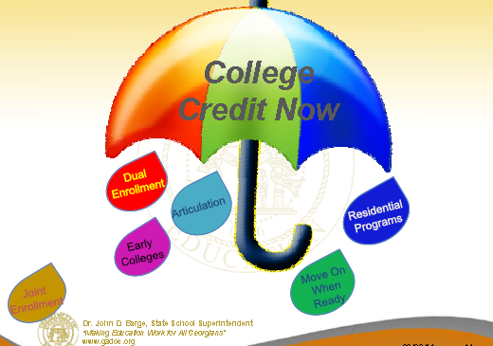

ACCEL Program:
A program funded by the state of Georgia via Georgia Student Finance Commission funds and administered by the Georgia Student Finance Commission for juniors (3rd year students) or Seniors (4th year students) to participate in an approved post secondary option, College Credit Now program. The ACCEL program encompasses two and four year colleges and universities as well as technical colleges.

ACCEL courses are core academic courses (English, math, science, social studies and world language) that are part of a degree program and that are offered to high school juniors and seniors during the high school day. Students must meet college admissions requirements and have flexibility in their schedule to attend class on the college campus. Beginning in the 2011-12 school year ACCEL courses DO NOT count against the maximum HOPE hours that a student can use in his/her lifetime. Students in ACCEL courses receive both high school and college credit. Grades achieved in those courses count towards the high school GPA.

This link on GACollege411 provides additional information: https://secure.gacollege411.org/Financial_Aid_Planning/Scholarships/Grants_and_Scholarships/Accel_Program.aspx

Articulated Credit:
Articulated credit is awarded by technical colleges after a student graduates from high school and only if there is an agreement between the college and the school district. This agreement guarantees that the high school coursework is equivalent to the college coursework. Students may request articulated credit within 18 months of graduating from high school. Most technical colleges require that students pass an end-of-course or exemption exam before credit will be awarded.

College Credit Now/Dual Enrollment:
This is the overall term used for a variety of dual enrollment programs. Two of these are ACCEL and MOWR (Move on When Ready). Students participating in College Credit Now enrollment may attend college outside of their high school day and on a college campus and calendar. Whether at a technical college or a 4-year university, most courses taken through College Credit Now are core academic courses and are paid for the state.

Dual Enrollment at a Technical College:
Dual enrollment courses at a technical college are courses that earn credit at both the high school and technical college and are paid for by the HOPE grant. These courses are only available at t technical college.

Joint Enrollment/HOPE:
Joint enrollment courses are offered to high school students, but credit is only issued by the technical college or college. These College Credit Now/Dual Enrollment courses are paid for by the HOPE Grant but DO NOT count against the maximum HOPE hours that a student can use in his/her lifetime. Since students receive college credit only, grades achieved in joint enrollment courses DO NOT count towards the high school GPA. No school district funds pay for these courses.

Move on When Ready (MOWR):
MOWR is a College Credit Now/dual enrollment opportunity for students to attend a postsecondary institution full-time during their junior (3rd year) and/or senior (4th year) year of high school. Students will receive high school credit and college credit simultaneously while attending college classes on the college campus as a full-time student. A full-time college student must take a minimum of 12 college hours. Approved college on-line courses can also be taken that meet high school graduation requirements. This link on the Georgia Department of Education website provides additional information: http://www.doe.k12.ga.us/Curriculum-Instruction-and-Assessment/CTAE/Pages/Transition-Career-Partnerships.aspx

Tuition is paid through local school system funds – materials, supplies, books, food, and transportation are the responsibility of the student. Students may live on campus or commute and the student is responsible for expenses related to these costs. MOWR classes DO NOT count against the HOPE Scholarship or Grant hours.

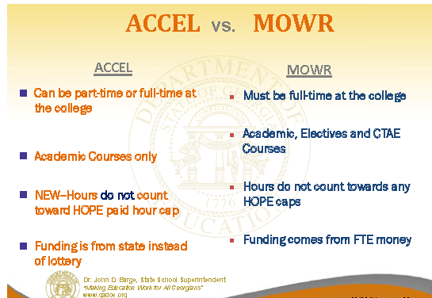

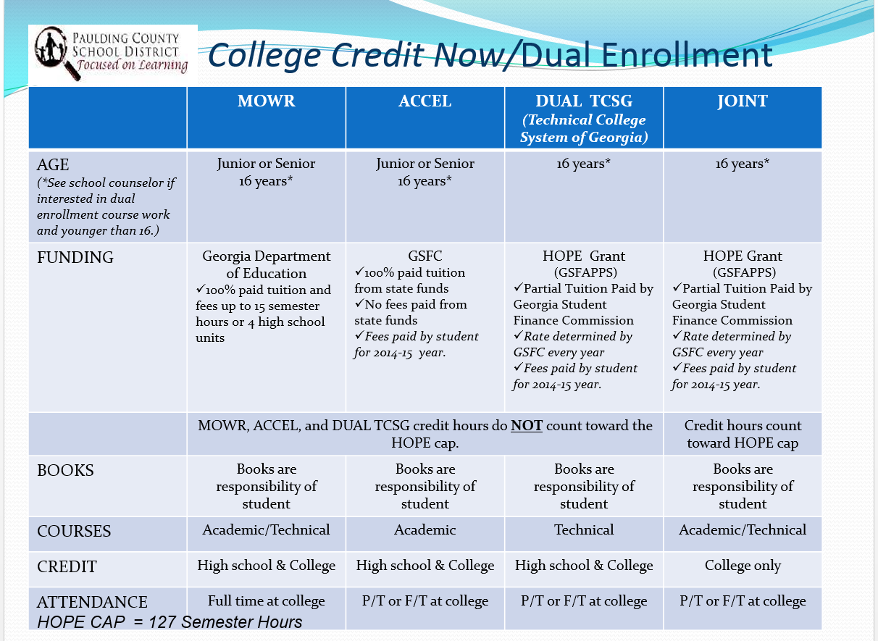

Using the Dual Enrollment information in this guide, complete the chart below:

ACCEL | Advanced Placement | Articulated Credit | Joint Enrollment | Move on When Ready | Work-Based Learning
 |  |  |  |  |  | Students must be classified by their high school as junior or senior
 |  |  |  |  |  | Students must be at least 16 years old
 |  |  |  |  |  | Students take college-level courses during the school day
 |  |  |  |  |  | Students work in the school or community during the school day
 |  |  |  |  |  | Coursework leads to a technical certificate
 |  |  |  |  |  | Courses may be academic or technical
 |  |  |  |  |  | College courses are academic only
 |  |  |  |  |  | Includes military training
 |  |  |  |  |  | Students work in the community during the school day
 |  |  |  |  |  | Students are on the college campus all day
 |  |  |  |  |  | Students travel to the workplace
 |  |  |  |  |  | Students travel to the college campus
 |  |  |  |  |  | Students are supervised by a high school teacher and receive high school credit for their work
 |  |  |  |  |  | Courses will county ONLY for college credit
 |  |  |  |  |  | College courses count for BOTH high school & college credit
 |  |  |  |  |  | Students receive credit within 19 months of high school graduation
 |  |  |  |  |  | Tuition and fees are paid for by HOPE Scholarship
 |  |  |  |  |  | Tuition and fees are paid for by HOPE Grant
 |  |  |  |  |  | Tuition and fees are paid by Georgia DOE; books are paid by student
 |  |  |  |  |  | Grades earned in the college courses WILL count towards your high school GPA
 |  |  |  |  |  | Grades earned in the college courses will NOT count towards your high school GPA
MAKE A PLAN

WORK-BASED LEARNING

Work-Based Learning:

The Work-Based Learning (WBL) program is designed to provide experience and activities that support a school to career transition. Students are allowed to work off campus in the business community during the school day to learn more about a chosen career. Students participating in WBL must be in grades 11 or 12 and at least 16 years of age. Students must also have a 2.0 GPA or higher, teacher recommendation, and good attendance and discipline. Students participating in WBL may be paid or unpaid for their work experience.
REQUIREMENTS FOR WBL
  - Students who are enrolled (or have completed) in a CTAE
  - Pathway can apply for the Work-Based Learning Program.
  - Students must be in grades 11 or 12
  - Students must be at least 16 years of age
      - Students must have good attendance, discipline, and teacher recommendations
  - Students must have a 75 Numeric GPA or higher

EMPLOYABILITY SKILL DEVELOPMENT (ESD)
  - Paid entry level work
  - Limited to one year
  - May or may not be linked to a specific pathway
  - Must have completed or be currently enrolled in a CTAE course

INTERNSHIP
- Can be paid or unpaid work experience
- Directly related to a student’s career pathway
- Can occur in the school or the work place
- Must have earned one credit in a CTAE pathway or closely related academic course

COOPERATIVE EDUCATION (CO-OP)
  - Paid work experience
  - Directly related to student’s career pathway
  - Enrolled in a course that is directly related to job placement

YOUTH APPRENTICESHIP (YAP)
  - Paid work in a highly technical, highly skilled position
  - Work in chosen career area
  - Student must have post-secondary education plans in chosen career area (earning a degree, licensing, or certification depending on career requirement)
  - For completion of YAP program students must have 2000 hours in high school and post-secondary institutions

MAKING A PLAN

OK, we’re almost there! By now, you should know more about you, your interests, and your high school and post secondary options. Let’s take just a minute to review:

Use the information on previous pages of this guide to answer the following questions:

- What is your career choice? _________________________
- What Career Pathway will you consider at the high school? ________________________________
- Do you know if that pathway is offered at the high school you will attend?
YES NO (circle one) If NO, what other pathway would interest you?
_________________________________________________
- How many units/credits of English/Language Arts will you need to meet graduation requirements? _____
- How many units/credits of Social Studies will you need to meet graduation requirements? _____
- How many units/credits of Science will you need to meet graduation requirements? _____
- How many units/credits of Math will you need to meet graduation requirements? _____
- How many units/credits of Health and Physical Education will you need to meet graduation requirements? _____
- How many units/credits of Career, Technical, and Agriculture (Pathway) and/or World Language, and/or Fine Arts (music, art, etc.)? _____
- Where would I find out information about the Advanced Academic Plans of Study/Pathway courses?
_______________________________________________________________________________________
- How many additional electives will you need to meet graduation requirements? _____
- What is a GPA? __________________________________________________________
- What postsecondary (after high school) plans do you currently have (circle all that apply):
4-year college 2-year college technical college special purposes school
apprenticeship military go to work Other ____________

BRIDGE ADVISEMENT GRADUATION PLAN DOCUMENT

This plan begins in 8th grade and is reviewed and updated annually until the fall of the senior year. This document is used to update the overall Program of Study also known as the Individual Graduation Plan in GACollege411. In August of your senior year, a Senior Letter is created by your school counselor and lists the final requirements for your graduation at the end of your fourth year.

Please note the two page BRIDGE Advisement Graduation Plan document in this guide.

INCREASE YOUR CHANCES FOR HIGH SCHOOL SUCCESS
Succeeding in high school is completely up to YOU! You will have teachers, counselors, administrators, friends, and parents/guardians to help, but ultimately YOU are responsible for and in control of everything you do during your high school career. The following helpful hints may help you stay on track:

- Make up your mind now to finish eighth grade in good academic standing. You not only need to do well in your classes, but you must also do well on the CRCT.

- Remember that your high school GPA is important! Your grade point average determines whether you will be able to participate in sports and some other after school activities. It also affects college acceptance and eligibility for HOPE and other scholarships.

- Don’t forget to ask for help. High school courses are designed to prepare you for college; they will be challenging. Your teachers are there to help you, but you will have to ask if you don’t understand the material. They are good in their subject area, but teachers cannot read your mind!

Setting goals is important to being successful, just like knowing where you are going is important to planning a trip. Now is the time to think about what you want, where you want to go, and how you are going to get there. Take some time to think about the following:

Short-term (immediate) Goals:

Define three short-term goals for this year. These may be personal goals, educational goals, or goals centered around family and friends. Example: “I want to get better at using the computer”.

Your goals should be challenging but also achievable and realistic. Push yourself, but set goals that you are capable of achieving with maximum effort.

Your goals should be enjoyable – you should truly want to work towards these goals. Your goals should also be flexible. As your priorities, interests, and skills change, your goals will change too.

Goal 1: ____________________________________________________

Goal 2: ____________________________________________________

Goal 3: ____________________________________________________

Intermediate Goals (2-5 years):

Use the same guidelines above. Example: “I want to get my driver’s license”.

Goal 1: ____________________________________________________

Goal 2: ____________________________________________________

Goal 3: ____________________________________________________

MORE ABOUT HIGH SCHOOL COURSES

The key to doing well in your high school courses is knowing how to select the right ones. Some courses have different levels of difficulty; others are offered only at certain grade levels; and several require that you complete previous courses. Using the information in the Academic section answer the following questions:

- What English courses are available for 9th grade students? _________________________________________________________________________
- In what grades are Advanced Placement (AP) English courses available? ________
- What are your choices for 9th grade math? ____________________________________
- What prerequisite must you meet to take Accelerated CCGPS Coordinate Algebra/Analytic Geometry A? _________________________________________________________________________
- What social studies choices will you have in 9th grade? If you take a social studies course in 9th grade,
is that course a core or elective course? _________________________________________________________________________
- Name two fine arts courses that you may take in 9th grade: _________________________________________________________________________
- How many levels of Spanish (other World Language) are available during your high school career? ______
- At what grade level will you take your required health course? _________________
- What other electives interest you? _________________________________________________________________________

This is a LOT of information about a LOT of courses! You need to spend some time thinking about and exploring your choices. If you are not sure which courses you should take, talk to your parents, your eighth grade teachers, or your middle school counselor. You might also look at your high school’s website. Visit www.paulding.k12.ga.us and click on Schools to find links to each of the individual high schools.

↑ Remember, your GPA is important. Be honest with yourself about the grades that you have made in the past, especially in language arts, science, social studies, and math. Your performance in these subjects and on the CRCT should have been very strong if you are considering honors or AP (Advanced Placement) classes.

MAKE A PLAN

Let’s make a plan!

With your career goals in mind, make your course requests and BRIDGE Advisement Graduation Plan.

Remember to choose electives that will further your career choice. Remember to consider if you want to be a College Credit Now student during your high school years.

Also remember that you must have four math, four science, four English/Language Arts, and three social studies along with ½ health and ½ physical education. You must add a minimum of two World Language courses if you plan to seek college admission.

Finally, we’re going to look at the big picture to make sure that you are getting all of your required units. After completing it on paper, you need to go to GAcollege411 (gacollege411.org) and enter this information under High School Planning in your Plan of Study also known as your IGP (Individual Graduation Plan).

If you like, you may also enter your defined goals in your GaCollege411 portfolio under Your Profile.


Your counselors will continue to assist you with your plans and make certain that you have completed each advisement step.

HELPFUL WEBSITES

Want to know more about life after middle school? Here are some helpful websites your might visit:

www.knowhow2go.org/middle_ready.php

www.aie.org/students/

www.vaview.org

www.learnmoreindiana.org/careers/exploring/Pages/RealWorld.aspx

www.driveofyourlife.org

www.breitlinks.com/careers/career_activities.htm

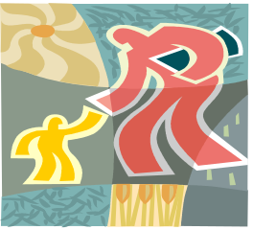
PERSONAL/SOCIAL DEVELOPMENT

Being a successful student is what school is about. Yet, we know that sometimes what
you think and feel may get in the way of academic success. If you are having problems
with friends or others, this may distract you from focusing on school. For this reason,
school counselors help you develop the following standards for success in your personal
and social life.

Standard A: Students will acquire the knowledge, attitudes, and interpersonal skills to help them understand and respect self and others.
Standard B: Students will make decisions, set goals and take necessary action to achieve goals.
Standard C: Students will understand safety and survival skills.
(Source: The American School Counselor Association National Model)

HOW SELF-AWARENESS HELPS YOU LEARN
When you purchase a new video game or hair dryer, you read the instructions, so you will know how everything works. You should do the same thing with your brain and think about developing your self-awareness. Determine your self-image, attitudes, and habits.
To build your self-esteem:
Be CONFIDENT and trust that you are a powerful person.
Know that everyone is unique and embrace others who are different than you are.
Do not be discouraged by the mistakes that you make.
Always treat others in a kind manner.
Be KIND to yourself.
Believe in yourself.
Think positively and distance yourself from negative people.
Do your best at all times and take pride in everything that you do.
To build your attitude:
Your attitude affects everything you do.
Your attitude will either energize or drain you.
A positive attitude opens your mind to many possibilities.
You always have the power to treat others with RESPECT.
To increase your positive habits:
Identify the bad habits that may prevent or slow you down from reaching your goals or potential.
Review your habits from time to time and see if you need to change a habit.

GOAL SETTING
Throughout high school, you begin evaluating your life, whether it is day-to-day details, a short term project, or a long-term project. A goal moves you toward something that you want to strive for or attain. Goals incorporate prioritizing, managing time, setting up a plan or schedule, and staying flexible.
GOALS WILL HELP YOU SEE YOUR PURPOSE CLEARLY!

GETTING CONNECTED TO OTHERS
You need the adults in your high school, so make an effort to form positive relationships with:
Teachers—Obviously, they are there to guide students and to help students learn the course content. However, they are not just interested in giving out homework and having you taking tests. Teachers can be great resources to help you with your career plans, especially as you learn what your favorite subjects are. Teachers also can be very good listeners for any type of issue that you are facing.
Professional School Counselors—His or her very reason for being at your school is to support you and see you succeed. Remember to discuss academic, personal/social, and career issues with your counselor. They will assist you in settling conflicts and making smart choices.
Other Adults—There are all types of adults who will support you —the resource office, school nurse, media specialists, and administrators are only a partial list.

JUST KEEP PEACE BULLYING PREVENTION PROGRAM - (Keep in touch with your school counselor regarding any issues that you have that fall under this Personal/Social Life Domain.)

PCSD Bullying Prevention Program
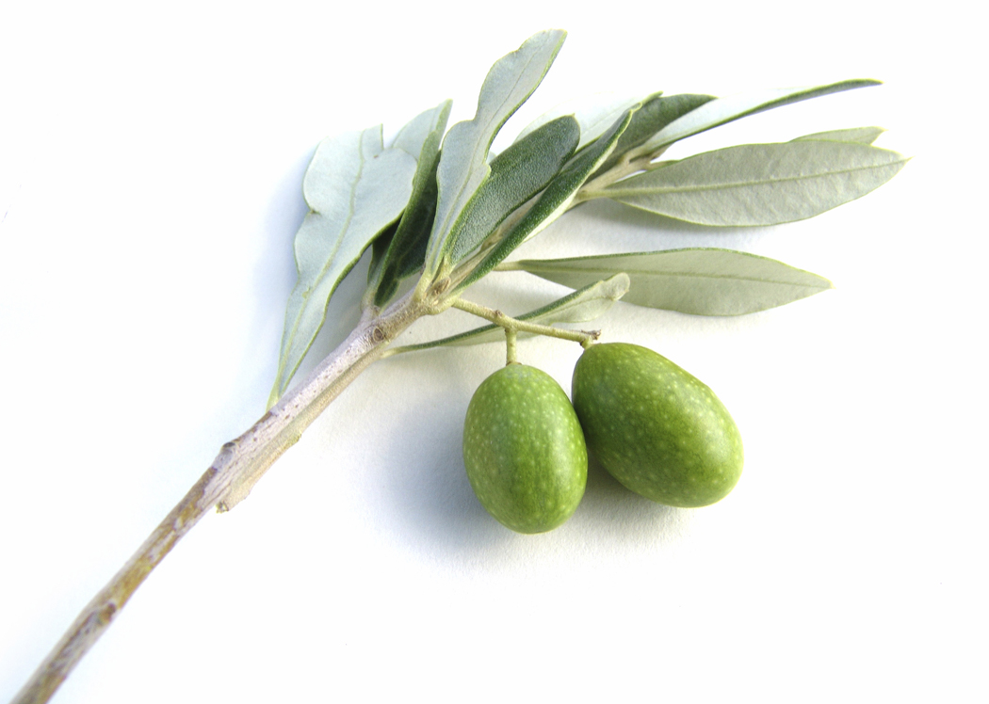
Just Keep Peace
The Bullying Prevention Program for the Paulding County School District is a multi-tiered approach which is designed from a proactive/preventative stance and provides a safe learning environment for all students. The overall framework of the program is based on the research-based Olweus Model. The name of this valuable program is Just Keep Peace. This program supports all students in grades K-12.

This program while introduced to you during your middle school years continues through all of a student’s high school years. The focus of the district program and all local school programs has at the center core the understanding that bullying is:
- a behavior that is repeated over and over by the same person
- intentional and causes distress, fear, and/or harm to the victim: takes into account how the victim perceives the bully’s intent
- power-based whereby the victim cannot defend himself/herself with the power imbalance being from physical strength, social status and/or emotional intimidation.

The district program believes in these best practices:
- The focus is on the social climate of the school so that the learning environment is positive
and norms are developed regarding bullying.
- Data is used to assess bullying at each school as well as at the district level to estimate the nature and prevalence of bullying.
- Through training sessions and workshops, information is shared so that both staff and
parents buy-in to support bullying prevention.
- A representative group is developed to support each school’s bullying prevention activities
and program plan and to assess data results.
- Training for administrators, faculty, and staff and presenting classroom guidance activities for
students include the definition of bullying, the effects of bullying, how to respond when bullying is observed, how to support others to prevent bullying, and when/how to report bullying.

The Bullying Circle is taught at all grade levels including high school, so that roles and reactions are understood. The circle has at the center the social and learning climate of the school with the students understanding the following roles:
1. Bully
2. Follower-may not be as ready to act
3. Disengaged Onlooker
4. Passive Defender
5. Possible Defender
6. Defender’s Supporter
7. Defender Who Helps the Victim

As you are already aware from you counselors who support you at the middle school level, bullying prevention takes active participation of administrators, counselors, teachers, other district personnel, parents and students along with the community. It takes all stakeholders to eliminate bullying and promote a positive learning environment. Every elementary, middle, and high school has a local school plan that has been written and submitted to the Director of Counseling Services.

In addition to bullying prevention, the district program addresses and supports the aftermath and consequences of a student who has bullied another student.

Please note: All school districts in Georgia will have a Bullying Prevention Policy and Protocol in place.

APPENDIX

Websites for the 21st Century Graduate
College Information

http://www.act.org provides information on the ACT and will allow you to register online.

http://www.collegeboard.com provides information on the SAT and will allow you to register online.
http://www.GAcollege411.org is an online, interactive tool that helps students make choices about careers, colleges, technical schools, and financial aid.
http://www.petersons.com is Peterson’s Guide to Colleges and Universities.
http://www.ncaaclearinghourse.net/ncaa/NCAA/common provides the NCAA Eligibility Guide
Career Information
http://careerpathsonline.com is the site for Career Paths.
http://collegeboard.com offers Career Browser.
http://www.GAcollege411.org provides career interest inventory and results information.
http://www.umsl.edu/services/govdocs/ooh20002002/1/htm is the Occupational Outlook Handbook.
http://www.todaysmilitary.com/app/tu/careers is the Military Career Center.
Scholarship/Financial Aid Information

http://www.college-scholarships.com is an all purpose college and scholarship information site which includes links to nine free internet scholarship search data bases, links to college websites and online applications, college admissions office email addresses and (mostly toll free) phone numbers, ACT and SAT prep information, and much, much more. The site has been the recipient of more than 25 internet awards and receives more than 150,000 visits each month.
http://www.ed.gov/studentaid.com is a federal government site for student financial assistance. There is a link to the U.S. Department of Education FAFSA (Free Application for Federal Student Aid). Remember no completed FAFSA application during the spring semester of your senior year means NO HOPE.
http://www.fastweb.com is the largest on-line scholarship search service.
http://www.GAcollege411.org is an online, interactive tool that helps students make choices about careers, colleges, technical schools, and financial aid.
http://www.get-recruited.com offers students a chance to be recruited by, and perhaps be offered scholarships to attend, colleges, universities and graduate schools throughout the United States. This service is absolutely free.
http://www.guaranteed-scholarships.com lists and describes scholarships offered by individual colleges and universities to all enrolled students meeting the specific criteria.
http://www.gsfc.org provides complete HOPE program eligibility requirements and provides answers to questions about this program.

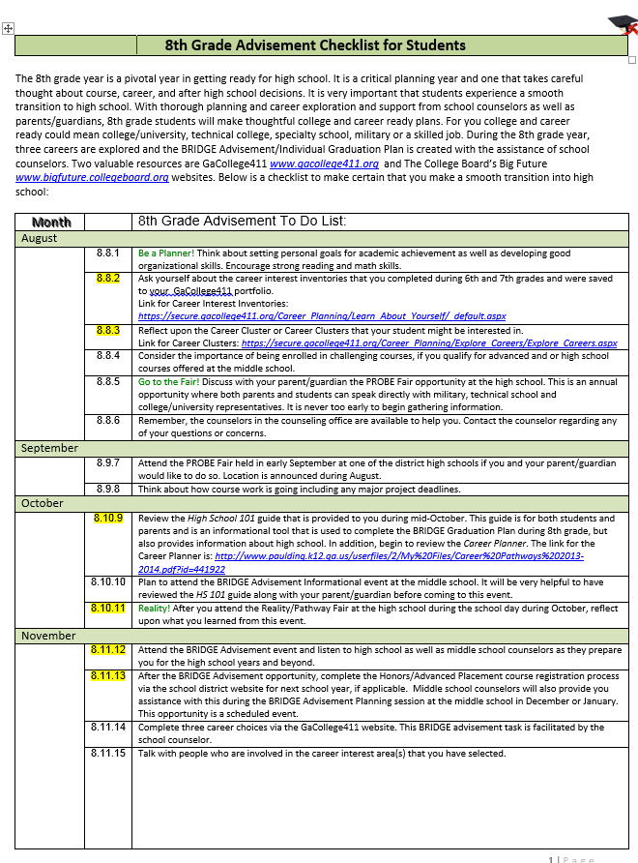

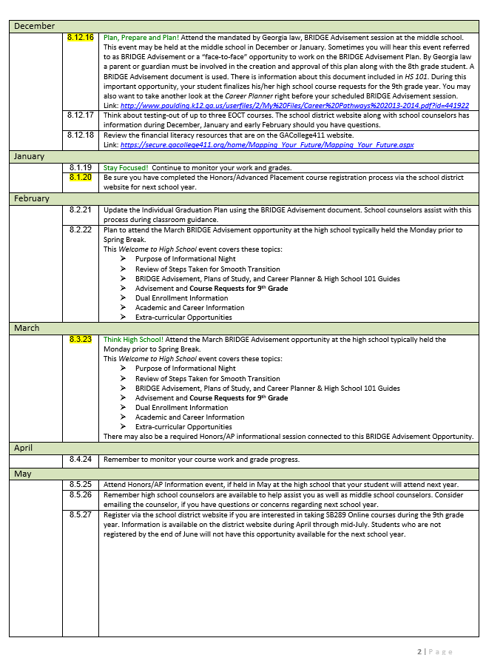

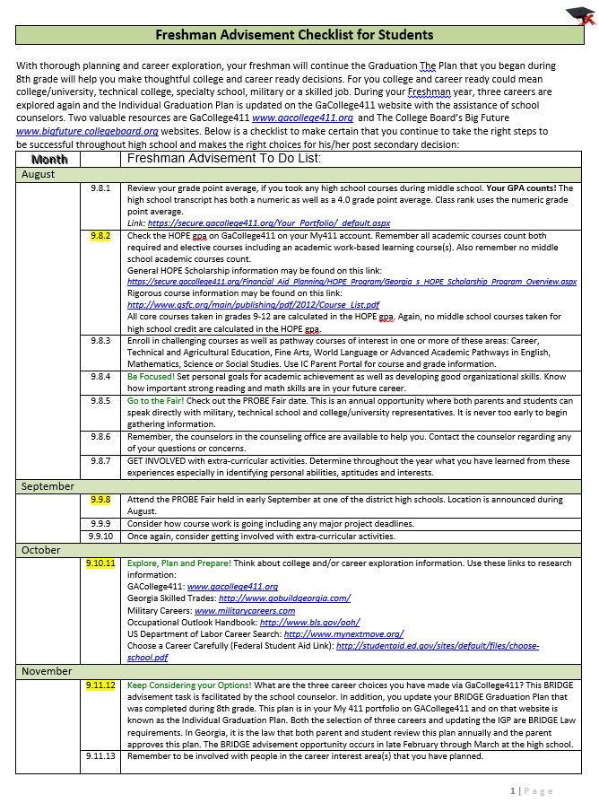

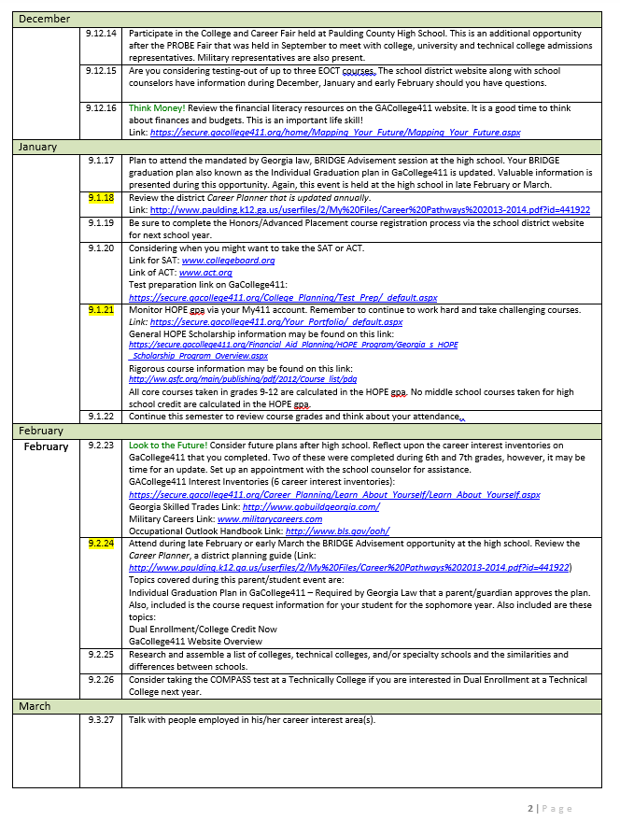

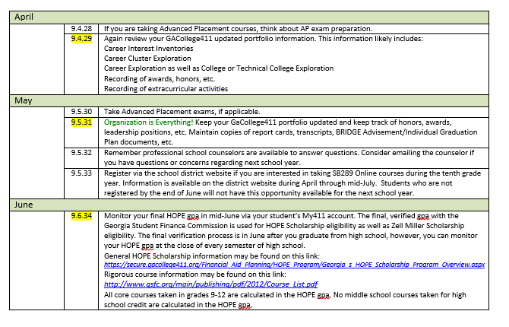
In addition to the previous advisement checklists in this guide, students may use the Guideways that are a part of their GACollege411 accounts at www.gacollege411.org. There is a guideway for grades 9, 10, 11, and 12 on this website.

9th Grade Guideway Source: www.gacollege411.org
This Guideway will walk students through parts of the system that are recommended for 9th grade students. The website will save wherever a student leaves off so that he/she can pick up later on.
In addition to annual goal setting, course planning and reflection, this Guideway lets students:
Discover interests and explore related careers
See work in action by job shadowing
Relate career pathways to college majors
Learn about how to pay for college

A SUCCESSFUL TRANSITION

Suggestions for Students

- Be aware that many students are anxious about moving to high school.
- Common concerns include the size of the school, worries about older students, worries about not having friends, and responsibilities of more challenging courses.
- It is normal to feel some anxiety about big changes.
- Attend summer orientation opportunities offered at each high school.
- Get Involved! Try different activities and look forward to meeting new people through these opportunities.
- Discuss your concerns with a friend, an adult, or an older sibling.
- Try to attend high school events, if you have not already done so, during your 8th grade year.
- Give it time! Do you remember how long it took for you to feel at home when you went from 5th to 6th grade?
- If you don’t understand something, don’t be afraid to ask questions.
- Consider using a study partner or study group and keep this group through high school.
- Take careful notes in class and consider reviewing these every night. Rewrite the notes or key them into word document on your computer, if you feel this will help you increase retention of the presented material.
- Take a break after school, however, have a set time for homework in a quiet area. Take frequent short breaks when doing homework.
- Read assigned topics that are in your textbook or assigned book ahead of time.
- Learn strategies for stress reduction that work well for you. Walking, playing a sport, listening or playing music, singing, talking to a friend, etc. will help relieve stress.
- Good study habits will pay off, not only in high school, but when you transition to college, technical college, or a work setting.
- Utilize an agenda book to help with organizational skills. Planning ahead of time to meet deadlines is key.
- Always be prepared and take an active role in your education! Learn about all the diploma requirements and courses you need to graduate from high school. Participate in the annual BRIDGE Advisement Graduation Plan advisement opportunities.

Congratulations! Having completed the journey through the academic and career sections of this handbook of information, you are now among a very select group of eighth graders. You will be entering high school better prepared to graduate and, hopefully, well on your way to the college and/or career of your choice. Just a few final thoughts:

- Remember you have to be present to win! Your high school attendance record impacts a lot of things: the ability to get a driver’s license; your eligibility to play sports; your chances of being accepted into college, the military or even getting a job.

- Keep your options open. Nothing that you have decided so far is set in stone. When things do change, be patient, be yourself, and be prepared to make good choices!

- Stay in control. Don’t lose track of what you want, where you are going, and how you are going to get there.

- And finally,

Enjoy your high school years!



East Paulding High School
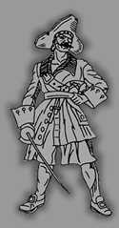
3320 East Paulding Drive
Dallas, Georgia 30157
www.eastpaulding.org

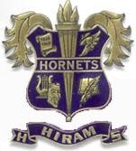
Hiram High School
702 Virgie Ballentine Drive
Hiram, Georgia 30141
www.hiramhigh.org


North Paulding High School
300 North Paulding Drive
Dallas, Georgia 30132
http://168.9.116.195/ischooldistrict/index.php?school_ID=40&district_ID=2

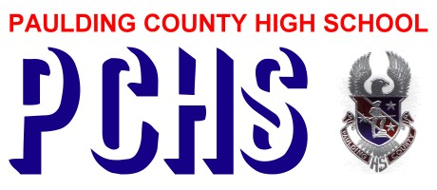
Paulding County High School
1297 Villa Rica Highway
Dallas, Georgia 30157

http://168.9.116.195/ischooldistrict/index.php?school_ID=41&district_ID=2

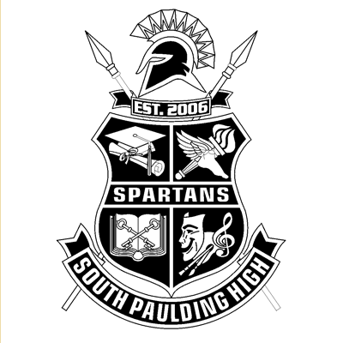
South Paulding High School
1364 Winn Road
Douglasville, Georgia 30134
http://168.9.116.195/ischooldistrict/index.php?school_ID=36&district_ID=2

