Name: ________________________________

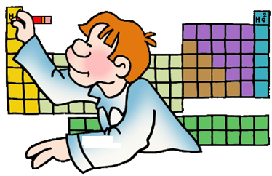

Date: _________________________________



**PowerPoint Worksheet**

**INTRODUCING THE PERIODIC TABLE**

1. What is the periodic table?
2. Who made the periodic table?
3. What ability did the periodic table have?

**INFORMATION ON THE PERIODIC TABLE**

1. How is each element represented on the periodic table?
2. Using the diagram below, label the parts of the element box.



1. In the shaded area to the right, draw the element box for the element that has an atomic mass of 107.87.
2. In the shaded area to the right, draw the element box for the element that has the element symbol Pt.

**ORGANIZATION OF THE PERIODIC TABLE**

1. How is the periodic table arranged?
2. What is each column on the periodic table called and how many of them are there?
3. What is each row on the periodic table called and how many of them are there?

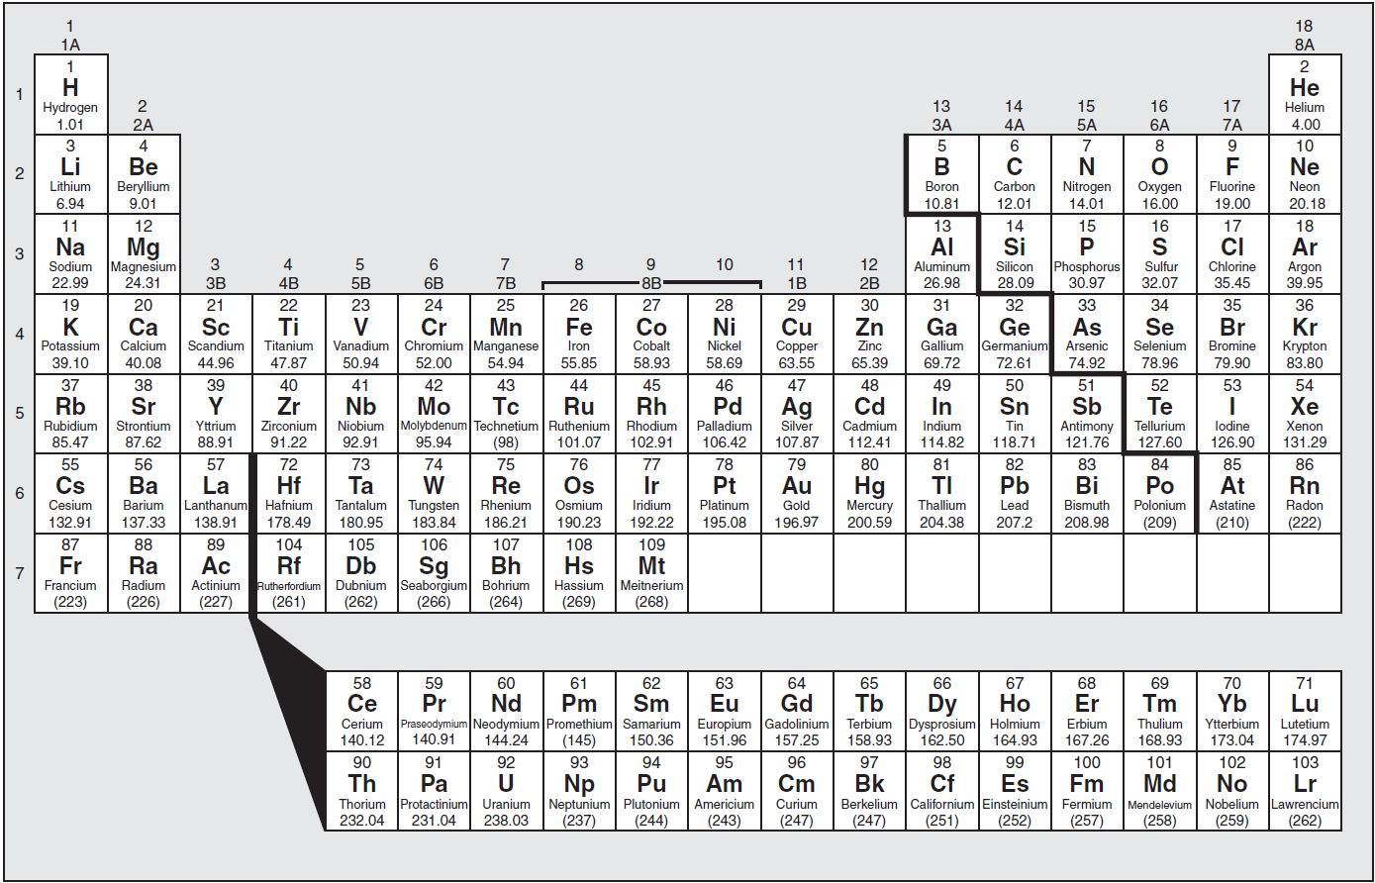

1. In the diagram able, identify and highlight the **zigzag** line. What is another name for the zigzag? Label it on the diagram above.
2. Describe where the **metals** are found on the periodic table. Label them “metals” on the diagram above.
3. Describe where the **non-metals** are found on the periodic table. Label them “non-metals” on the diagram above.
4. Which is the **only non-metal element** that is not located with the rest? Circle it and label it “non-metal”.
5. Where are the **metalloids** found and how many of them are there?
6. Using a pencil crayon, color in the metalloids on the diagram above and label them “metalloids”.

**METALS, NON-METALS AND METALLOIDS**

1. Fill in the chart below to **summarize** **the metals, non-metals and metalloids**.

|  |  |  |  |
| --- | --- | --- | --- |
| **Class of Elements** | **State of Matter** | **Properties** | **Examples of Elements** |
| Metals |  |  |  |
| Non-metals |  |  |  |
| Metalloids |  |  |  |

**CHEMICAL FAMILIES ON THE PERIODIC TABLE**

1. What is a **chemical family**?
2. Identify, color in, and label the important groups of the periodic table on the diagram below.



1. Fill in the chart to **summarize** information on important groups on the periodic table.

|  |  |  |  |
| --- | --- | --- | --- |
| **Name of Group** | **Group #** | **Examples of Elements in this Group**  **(use symbols)** | **Description of Properties and Facts** |
| alkali metals |  |  |  |
| alkaline earth metals |  |  |  |
| halogens |  |  |  |
| noble gases |  |  |  |
| transition metals |  |  |  |
| lanthanides |  |  |  |
| actinides |  |  |  |

Name: ________________________________



Date: _________________________________

**ANSWER KEY**



**PowerPoint Worksheet**

**INTRODUCING THE PERIODIC TABLE**

1. What is the periodic table?

**It is a chart that organizes the elements by their increasing atomic numbers as well as by their physical and chemical properties.**

1. Who made the periodic table and when was it created?

**A Russian chemist and inventor named Dmitri Mendeleev created the periodic table in 1869.**

1. What ability did the periodic table have?

**The periodic table was designed to make room for and predict the existence of elements that had not yet been discovered.**

**INFORMATION ON THE PERIODIC TABLE**

1. How is each element represented on the periodic table?

**Each element on the periodic table is represented by a box, in which contains basic information above each element.**

1. Using the diagram below, label the parts of the element box.



**element name**

**atomic number**

**element symbol**

**atomic mass**

1. In the shaded area to the right, draw the element box for the element that has an atomic mass of 107.87.





1. In the shaded area to the right, draw the element box for the element that has the element symbol Pt.

**ORGANIZATION OF THE PERIODIC TABLE**

1. How is the periodic table arranged?

**The periodic table is arranged in columns and rows.**

1. What is each column on the periodic table called and how many of them are there?

**Each column is called a GROUP and there are 18 of them.**

1. What is each row on the periodic table called and how many of them are there?

**Each row is called a PERIOD and there are 7 of them.**



***STAIRCASE***



***NON-METALS***

***METALS***

***METALLOIDS***

1. In the diagram able, identify and highlight the **zigzag** line. What is another name for the zigzag? Label it on the diagram above.

**Another name for the zigzag is the STAIRCASE.**

1. Describe where the **metals** are found on the periodic table. Label them “metals” on the diagram above.

**The metals are found on the LEFT side of the staircase.**

1. Describe where the **non-metals** are found on the periodic table. Label them “non-metals” on the diagram above.

**The non-metals are found on the RIGHT side of the staircase.**

1. Which is the **only non-metal element** that is not located with the rest? Circle it and label it “non-metal”.

**HYDROGEN is the only non-metal element that is not located with the rest.**

1. Where are the **metalloids** found and how many of them are there?

**The metalloids are found directly around the staircase. There are 8 of them.**

1. Using a pencil crayon, color in the metalloids on the diagram above and label them “metalloids”.

**METALS, NON-METALS AND METALLOIDS**

1. Fill in the chart below to **summarize** **the metals, non-metals and metalloids**.

|  |  |  |  |
| --- | --- | --- | --- |
| **Class of Elements** | **State of Matter** | **Properties** | **Examples of Elements** |
| Metals | * **All solids except for mercury** | * **Lustrous, silvery, ductile, malleable, electrically conductive, and some are magnetic** | **Ag, Cu, Hg, Li** |
| Non-metals | * **Most gases except for Br which is a liquid and C, P, S, Se and I which are solids.** | * **Colorless, or varying colors, non-malleable, non-ductile, brittle when solid, poor electrical conductors and non-magnetic.** | **C, S, Ne, Br, Cl, N** |
| Metalloids | * **All solids** | * **Have properties of both metals and non-metals.** * **Have a metallic luster, brittle and have a medium to good electrical conductivity.** | **B, Si, Ge, As** |

**CHEMICAL FAMILIES ON THE PERIODIC TABLE**

1. What is a **chemical family**?

**It is a group of elements that have similar properties.**

1. Identify, color in, and label the important groups of the periodic table on the diagram below.

**Group 1: alkali metals**

**Group 18: noble gases**



**Group 2: alkaline earth metals**

**Group 17: halogens**

**Groups 3-12: transition metals**

**Elements 57-71: Lanthanides**

**Elements 89-103:Actinides**

1. Fill in the chart to **summarize** information on important groups on the periodic table.

|  |  |  |  |
| --- | --- | --- | --- |
| **Name of Group** | **Group #** | **Examples of Elements in this Group**  **(use symbols)** | **Description of Properties and Facts** |
| alkali metals | **1** | **Li, Na, K, Rb, Cs, Fr** | * **All soft silvery metals.** * **Most reactive of all the groups of metals.** * **Has one valence electron – loses to form ion in a compound.** * **Get more reactive as you go down the group.** * **Francium is the most reactive in the group.** * **All reactive with water, so must be stored under mineral oil.** |
| alkaline earth metals | **2** | **Be, Mg, Ca, Sr, Ba, Ra** | * **These are all silvery metals.** * **Also reactive with water.** * **Has two valence electrons.** * **They get more reactive as you go down the group.** * **The most reactive in this group is Radium.** |
| halogens | **17** | **F, Cl, Br,**  **I, At** | * **All non-metals.** * **Found in all three states: F & Cl are gases, Br is a liquid and I and As are solids.** * **Has seven valence electrons – gains an electron to form stable ion in a compound.** * **Get more reactive as you go up the group.** * **Fluorine is the most reactive.** |
| noble gases | **18** | **He, Ne, Ar, Kr, Xe, Rn** | * **All non-metals and gases.** * **Have full outer orbitals 🡪 unreactive** * **They are non-reactive elements and therefore do not form compounds** |
| transition metals | **3-12** | **Zn, Au, Pb, Hg, Ni, Cu** | * **These are all metals and solid except for mercury which is a liquid.** * **They have typical metallic properties and many of them are the most commonly known metals e.g. iron, copper, tin, lead, silver, gold etc.** |
| lanthanides | **elements 57-71** | **La, Ce, Eu** | * **These are all metals located in additional rows below the main periodic table.** * **They are all solids.** * **They have been previously misleadingly labeled “rare earth metals”.** |
| actinides | **elements**  **89-103** | **Ac, Pu, U, Cm** | * **These are all radioactive, solid metals.** * **They spontaneously combust in the presence of air.** |

**Created by Anh-Thi Tang – Tangstar Science**

**Copyright © May 2013 Anh-Thi Tang (a.k.a. Tangstar Science)**

All rights reserved by author.

This document is for your personal classroom use only.

This entire document, or any parts within, may not be electronically

distributed or posted to any website.